**Design and Development of Prognosis based Body Monitoring and reporting System using Time Series Analysis**

**M.Tech. Dissertation in**

**Department of Computer Science and Networking**

**Submitted By : Limbasiya Pari R.**

**Reg. No. : 15ETCS037002**

**Supervisors : Sagar D.**

**August – 2017**

**FACULTY OF ENGINEERING AND TECHNOLOGY**

**M. S. Ramaiah University of applied sciences**

**Bengaluru -560 054**

**FACULTY OF ENGINEERING AND TECHNOLOGY**



# *Certificate*

*This is to certify that the Dissertation titled* ***“Design and Development of Body Monitoring and Reporting System using Time Series analysis”*** *is a bonafide record of the work carried out by Ms. Limbasiya Pari R., Reg. No. 15ETCS037002 in partial fulfilment of requirements for the award of M. Tech. Degree of M. S. Ramaiah University of Applied Sciences in the Department of Computer Science and Engineering.*

**August – 2017**

**Asst. Prof. Sagar D.**

Supervisor

**Prof. Raghavendra Kulkarni Prof. H. K. Narahari**   
Head–Dept. of CSE Dean-FET

Declaration

**Design and Development of Body Monitoring and Reporting system using Time Series Analysis**

The dissertation is submitted in partial fulfilment of academic requirements for the M.Tech. Degree of M. S. Ramaiah University of Applied Sciences in the Department of Computer Science and Engineering. This dissertation is a result of my own investigation. All sections of the text and results, which have been obtained from other sources, are fully referenced. I understand that cheating and plagiarism constitute a breach of University regulations, hence this dissertation has been passed through plagiarism check and the report has been submitted to the supervisor.

**Signature :**

**Name of the Student : Ms. Limbasiya Pari R.**

**Reg. No. : 15ETCS037002**

**Date :**

# Acknowledgements

I intend to convey my sincere thanks to my project supervisor Prof. Sagar D., Asst. Professor, Computer Science and Engineering Department for  
suggesting the dissertation topic and mentoring me throughout the project work.

I would like to thank Dr. R. V. Kulkarni, Head of Computer Science and Engineering Department who has supported through the project with his knowledge and valuable inputs.

I am very obliged to Dr. S. R. Shankarpal, Vice Chancellor, Dr. Govind. R. Kadambi, Pro Vice Chancellor and Dr. H. k. Narahari, Dean whose emphasis for quality work helped me keep my focus on my project work and complete it.

I would like to further sincerely thank the manager of M. S. Ramaiah University of Applied Sciences for providing an excellent environment throughout my studies.

Finally, I want to express my honest regards to my beloved parents for their blessings, my family and my fellow classmates for helping me and for their kind wishes for the accomplishment of this project.

Limbasiya Pari R.

15ETCS037002

# Abstract

In today’s world, Health is major concern for every human beings on the planet. Because of delay in treatment many of the humans died. Now it is possible because of science and technology to identify and take correct actions for any disease. In most of the cases, if considering health problems are connected with and due to problems in heart. In this time, there are many gadgets available for the improvement of health system with the help of technology. But those gadgets are only for monitoring the data of body.

Body diagnosis is the process of identifying a condition, disease, disorder or problem by systematic analysis of the background history with the current evaluated test result. Effective prognosis is not possible without effective diagnosis. To increase the level of health consciousness in any person with providing some comfort this thesis work proposed with one system. The system is able to collect the data of person’s heart rate and from that it will predict the value for prognosis and send the notification through email.

In this thesis based on designed system, it will measure the heart rate and forward the value for further calculations in simulated model in LabVIEW software. Analysis is performed on the data fetched through NodeMCU board connected with pulse sensor, by using ARMA model for time series prediction analysis. System compares the value with threshold set value and decides the actual prediction for the given input to that. The predicted value and notification for any change in functionality of heart sent over the SMTP protocol to the registered Email account. Because of the designed system it is possible to predict and notify the person before criticality to be reached.

# Table of Contents

*Certificate* II

Declaration III

Acknowledgements IV

Abstract V

Table of Contents VI

List of figures XII

List of tables XV

1. Introduction 16

1.1 Introduction 16

1.2 Motivation 17

1.3 Organization of thesis 17

2. Literature Review 19

2.1 Background theory 19

2.1.1 Data mining 19

2.1.2 Data mining modelling and Methods based on classification: 20

2.1.2.1 Support vector machine (SVM): 20

2.1.2.2 Neural Networks (NN): 20

2.1.2.3 Decision Trees: 21

2.1.2.4 Gaussian Mixture Models: 22

2.1.2.5 Hidden Markov Models: 22

2.1.2.6 Rule-Based Methods: 23

2.1.3 Data mining modeling and technique based on the clustering: 23

2.1.3.1 K-means: 23

2.1.3.2 K-medoids: 23

2.1.3.3 EM clustering: 24

2.1.3.4 Outlier detection algorithm 24

2.1.4 Prognosis based techniques 24

2.1.4.1 Model based prognostics: 25

2.1.4.2 Experience/Probability based prognostics: 26

2.1.4.3 Evolutionary models for prognostics: 26

2.1.5 Internet of Things (IoT) 26

2.1.6 Biomedical application based sensor 28

2.1.7 Body monitoring systems: 30

2.1.7.1 Patient monitoring systems to ensure security 30

2.1.7.2 Health monitoring using WSN: 30

2.1.7.3 Patient monitoring with the help of mobile phones: 30

2.1.7.4 Patient monitoring using Bluetooth enabled device: 31

2.1.7.5 Health Monitoring Using Body Sensors: 31

2.1.8 Wireless Technology: 31

2.1.8.1 Wireless Fidelity (Wi-Fi): 31

2.1.8.2 WIMAX: 32

2.1.8.3 Bluetooth Technology: 32

2.1.8.4 GSM technology: 33

2.1.8.5 ZigBee: 34

2.1.9 Time Series Analysis Model: 34

2.1.9.1 Linear regression: 34

2.1.9.2 Smoothing in time series analysis: 34

2.1.9.3 Autoregressive (AR) model: 34

2.1.9.4 Moving Average models: 35

2.1.9.5 Autoregressive integrated moving average (ARIMA) model: 35

2.1.9.6 ARCH/GARCH models: 36

2.2 Literature Review 37

2.2.1 Overview of Papers and Journals Referred 37

2.2.2 Literature Summary 46

2.3 Problem Formulation 55

2.3.1 Identification of Research Gaps 55

2.3.2 Research questions the dissertation would like to address 55

3. Problem Statement 56

3.1 Title 56

3.2 Aim 56

3.3 Project Objectives 56

3.4 Methods and Methodology 57

4. Design and Implementation 59

4.1 Requirement analysis 59

4.1.1 Functional Requirements 59

4.1.2 Non-functional Requirements 60

4.2 System Specifications 60

4.2.1 Hardware requirements 60

4.2.1.1 Embedded boards 60

4.2.1.2 Sensors 64

4.2.1.3 IoT module: 65

4.2.1.4 Laptop 67

4.2.2 Software requirements 68

4.2.2.1 Arduino IDE: 69

4.2.2.2 LabVIEW: 69

4.2.3 Selected System components and Development costing 71

4.3 Design Specification 72

4.4 System Design 73

4.4.1 Block diagram of system 73

4.4.2 Schematic Diagram 75

4.4.3 Flow chart of system 75

4.5 Implementation of System 77

4.5.1 Hardware Setup: 78

4.5.2 Software Setup: 78

4.5.2.1 Simulation set up of NodeMCU and Arduino IDE: 79

4.5.2.2 Simulation Set-up in LabVIEW: 84

4.5.3 System Implementation and Design in LabVIEW 87

4.5.3.1 Implementation between NodeMCU and Arduino IDE 87

4.5.3.2 Design in Labview Using TSA ARMA Modeling and Prediction: 93

4.5.3.3 Graphical User Interface in LabVIEW: 97

4.5.3.4 Design in LabVIEW for SMTP protocol: 98

4.5.3.5 GUI design in LabVIEW for SMTP Protocol: 99

4.5.3.6 Communication between Raspberry Pi and Cloud: 100

4.6 System Integration: 101

5. Results and Discussions 102

5.1 Unit Testing 102

5.2 Integration Testing 106

5.3 System level Testing 107

5.4 Result Analysis 109

6. Conclusions and Future Directions 114

6.1 Summary of Work 114

6.2 Conclusion 114

6.3 Future Work 115

References 1

# List of figures

**Figure 2. 1** **Basic process of DM technique** 19

**Figure 2. 2** **Prognosis based techniques comparison** 24

**Figure 2. 3** **IoT in Healthcare** 27

**Figure 4. 1** **Raspberry Pi 3 model B+** 63

**Figure 4. 2** **Pulse sensor** 65

**Figure 4. 3** **Pinout Diagram of NodeMCU V0.9** 67

**Figure 4. 4** **Arduino IDE software** 69

**Figure 4. 5** **LabVIEW software** 70

**Figure 4. 6** **High level Block diagram for system** 73

**Figure 4. 7** **low level Block diagram for system** 74

**Figure 4. 8** **schematic Diagram of the System** 75

**Figure 4. 9** **Flow chart of the System** 76

**Figure 4. 10** **Hardware setup of System developed** 78

**Figure 4. 11** **Installing IDE** 79

**Figure 4. 12** **Preference Dialog box** 80

**Figure 4. 13** **Preference Dialog box for URL Path** 81

**Figure 4. 14** **Board manager Dialog** 82

**Figure 4. 15** **Determining COM port** 83

**Figure 4. 16** **configuring COM port Speed** 83

**Figure 4. 17** **Upload the code** 84

**Figure 4. 18** **Create Project** 85

**Figure 4. 19** **Create a new VI** 86

**Figure 4. 20**  **Front panel window for Create project** 86

**Figure 4. 21** **Block Diagram Window for Create new Project** 87

**Figure 4. 22** **Initialization of library** 88

**Figure 4. 23** **Print the Wi-Fi is connected** 89

**Figure 4. 24** **Set password and SSID for Wi-Fi connection** 89

**Figure 4. 25** **Set Thing speak channel KEY** 90

**Figure 4. 26** **Pulse Sensor Code** 90

**Figure 4. 27** **Fetch Pulse Value** 91

**Figure 4. 28** **SET Counter value** 91

**Figure 4. 29** **calculate Heart rate** 92

**Figure 4. 30** **ARMA Modelling and Prediction in LabVIEW** 93

**Figure 4. 31** **Graphical User Interface for ARMA Modeling and Prediction** 97

**Figure 4. 32** **SMTP Protocol Design** 98

**Figure 4. 33** **SMTP Protocol design** 98

**Figure 4. 34** **GUI Protocol for SMTP Protocol** 99

**Figure 4. 35** **Python code for fetch data from cloud** 100

**Figure 4. 36** **System setup after Integration** 101

**Figure 5. 1** **pulse sensor Testing** 103

**Figure 5. 2** **NodeMCU V0.9 Testing** 103

**Figure 5. 4** **SMTP Protocol Testing** 104

**Figure 5. 3** **Raspberry Pi Testing** 104

**Figure 5. 5** **Results of Predicted Series** 108

**Figure 5. 6** **Pulse sensor Reading** 109

**Figure 5. 7** **Raspberry Pi convert Data file into Text file** 110

**Figure 5. 8** **Sensor Data send to cloud** 110

**Figure 5. 10** **GET Criticality Notification through E-mail** 111

**Figure 5. 9** **Get E-mail with Predicted Value and message for Criticality of disease** 111

**Figure 5. 11** **Prediction Accuracy Difference between EXCEL and LabVIEW** 112

# List of tables

**Table 2. 1**  **Biomedical Sensor and its application** 28

**Table 2. 2**  **Technical properties of GSM** 33

**Table 2. 3**  **Literature summary for referred papers** 46

**Table 3. 1** **Methods and Methodology to achieve defined objectives** 57

**Table 4. 1** **Embedded boards comparison** 60

**Table 4. 2**  **IoT Module boards comparison** 64

**Table 4. 3**  **Software available for simulation design** 67

**Table 4. 4**  **Selected system components and total costing for development** 70

**Table 4. 5** **Functional blocks and its working** 92

**Table 5. 1**  **Unit testing for hardware** 103

**Table 5. 2** **Integration Testing** 106

**Table 5. 3** **System level testing** 107

# 1. Introduction

## 1.1 Introduction

Humans are very important creation of God on this earth. Human health and well-being are the most important components for permanence. It is important to be up to date for all current situation of our own body to live good quality of lifestyle. The role and the importance of health care systems in the quality of life and social health in modern society, have been broadly well recognized. People are not that much dedicated for their health because of social environment and their day to day life. Though exercise and diets are good foundation, maintaining health is too complex and expensive task.

Due to fast life people do not have that much time to go for regular checkups and to keep their health status up to date. To solve this kind of issues, some healthcare systems developed for particular health issues. The systems are already exists which continuously monitors the condition of people at every instance of time and if any abnormality found in their body it will help to notify the person as well as physicians. Also in the era of smart world, Internet of Things (IoT) plays important role to make healthcare such an easy task. New developed healthcare monitoring systems are pre-designed with the IoT features so that not necessary for person to carry big system it can be wearable device like a wrist watch.

Today in market many systems available in the form of bands which are wearable on your wrist to calculate pulse counts, to monitor the number of steps walked, distance, blood pressure, how much calorie burn etc. Healthcare systems can be classified as diagnosis and prognosis systems. All these systems only provide the data about the person’s health and stores it as a history. It is categorized in diagnosis system.

Prognosis comprises the situation of person that the one will be in critical stage but no any systems available for that kind of analysis called prognostics. The use of analytics here can enhance accuracy, allow prior detection, enable personalization, and reduce cost by reducing expensive lab processes that are pointless.

## 1.2 Motivation

With the advanced technologies available like IoT, it is possible to save patients even the doctor is not available at that particular place. At the time of any help required from doctor, patient do not have to go and meet him personally. Doctor can remotely identify the problem and can suggest primary actions to the person as per the problem detected. Before a decade of time, So many people lost their lives because of unavailability of doctors at that place. But thanks to technology it is possible to measure and maintain health records by monitoring the body conditions on remote locations.

For more advanced and smart systems for healthcare, it requires more analysis. Diagnosis of body make a database for patient’s health chart. This data is of no use only it will get recorded as a history of system data. To utilize the data by doing advance analysis and to identify exact time in which the patient will reach the critical stage, it is required to design a new algorithm for existed healthcare systems. Rather than only monitoring, storing and sending notification to doctors about abnormal conditions, also it is essential to provide time limit for serious situation before it happens. Based on these kind of analysis not developed yet it can be designed for betterment of human lives and to increase the standard of good society with healthy environment.

## 1.3 Organization of thesis

The dissertation has six chapters which include an introduction to the topic, background theory and literature survey, problem statement, design and implementation, results and discussion and conclusion. The first part of dissertation includes brief about the healthcare monitoring systems and also discussed about how IoT can be include with that. The next part comprises detail descriptions about data mining, prognosis based techniques, IoT, biomedical sensors and their applications, body monitoring systems and reporting systems etc. In third part of thesis, the functionality of work and expected results that has been implemented is presented. Rest of the parts includes design specifications, implementation, and remarks for obtained results and reviews the work with some proposals for how to expand the work done by additional development. The organization is briefly listed below,

Chapter 1: It gives introduction about healthcare monitoring systems and some existed technologies to improve the standard of healthcare systems.

Chapter 2: In this chapter, study of different biomedical sensors and their applications discussed also body monitoring and reporting system explained. Some prognosis based techniques also written.

Chapter 3: This chapter gives important information about dissertation like, title of project, aim of the project. For more to that major objectives of work also listed followed by listed methods to achieve objectives.

Chapter 4: Main part of the thesis discussed in this chapter. Requirements analysis for the work with design constraints like, block diagram, flow chart and algorithms etc. explained and written in this.

Chapter 5: After implementation stage, results of the work presented along with relevant discussion based on the results found in this chapter.

Chapter 6: Last chapter of the thesis which includes the summary and concluded with limitations. In addition to that future expansion also discussed for the developed system.

# 2. Literature Review

The chapter comprises of three topics, background theory and the overview of the papers, literature gaps identified and the summary of the papers referred. Technical papers and documents which are relevant to the topic are considered and reviewed.

## 2.1 Background theory

This section includes the background study on the topics of data mining, prognosis based techniques, IoT, biomedical sensors and their applications, body monitoring systems and reporting systems etc.

### 2.1.1 Data mining

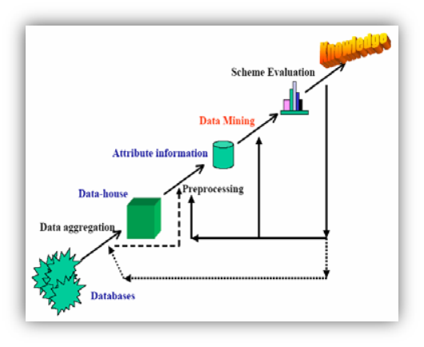In health monitoring system, data mining (DM) technique provide potential solution for quickly and correctly handle a large quantity of monitoring data analysis. DM technique to meet the need of various field like business management, production control, market analysis, engineering design and science exploration. “The nontrivial process of identifying valid, novel, potentially useful, and ultimately understandable patterns in data” [Duan Z, 2006].

**Figure 2. 1 Basic process of DM technique**

Data mining technique mainly focus on five role that is Association analysis, Classification and prediction, Concept description, Outlier analysis, Cluster analysis. Clustering, Principal component analysis (PCA), Rough set, Fuzzy set, Support vector machine (SVM), Decision tree (DT), Case-based reasoning (CBR), Genetic algorithm (GA), Artificial neural networks (ANNs), Visualization and multidimensional data analysis different methodologies available for data mining. Basic process of DM technique shown in figure 2.1.

### 2.1.2 Data mining modelling and Methods based on classification:

When more number of sensor set up in an application for example healthcare, huge amount of data can be produced. This data is multivariate with possible dependencies like sense data, appropriate data processing technique and methods are important. Most common algorithm mention above. Each algorithm explain with technical specification with greatest descriptive example on how algorithm has been applied in healthcare services. In this case data normally classify into two categories as a normal and abnormal.

#### 2.1.2.1 Support vector machine (SVM):

In a healthcare department the SVM technique most probably used with ECG, HR, and SpO2 and which are considered as short term and interpreted form. Binary classifier version of SVM is applied to the ECG signal for detect the patient`s condition and categorized the normal and arrhythmia classes. SVM methods of result is much better rather than the other kernel. Using the SVM algorithm we can identify the bed indentation in the focus of the chronic gastritis and arthritis with binary classifications of normal and abnormal radial pulses of ECG.

However, SVM technique is not suitable to integrate field information with the purpose of use metadata or symbolic information effortlessly with the measurements from the sensors. SVM could not be useful to invention the unexpected information from unlabeled data.

#### 2.1.2.2 Neural Networks (NN):

For the classification and prediction purpose the Neural Networks (NN) is an artificial intelligent approach. Mainly NN method model is used for data by knowledge the known classification of the data record with the predicted classes of the records data with the intention of expand the network weight for the next iteration. Presently, NN is the most popular data mining method due to the admissible predictive performance and it is mainly applicable to highly nonlinear system such as physiological records where the correlation of the input parameter is not easily measureable.

In a medical domain, wide range of the diagnosis and decision making task has been done using NN method. It is applied for multi sensor network application so as to handle the sophisticated analysis of multivariate data. For the estimate the quality of the pulse in PPG, multi-layer perceptron (MLP) neural network is used. In this network individual signal quality metrics given as input and improve the number of nodes unknown layer in validation iterations. NN method is used as three layer network to extract and classification of the data for location, activity and heart rate variability (HRV) pattern.

For predict the blood glucose level the Replicator Neural Network (RNN) is suggested for anomaly and outlier detection. They designed the NN network with 11 input variables and one output node for predict the BG level with each layer has an 8 neurons.

In data mining, the NN method is black box progress and it is not counted as portable technique to certainly apply for diverse data sets. Generally, NN technique is used for decision making in clinical condition with huge and complicated data sets.

#### 2.1.2.3 Decision Trees:

Decision trees method is one of the significant and accurate discrimination method for selected features which provides an efficient representation of rule classification. This method is used to identify robust features for initial splitting the input data by creating a tree model. For complex and noisy data, C4.5 algorithm which is use to estimating the error rate of initial node and make a more efficient sub-tree.

For example, the tree is designed with bio sensors data in two layers of emotion discriminations. Rule-based method applied classifier to make a proper decision. This method is compatible with input parameters like skin temperature, cooling actuation, and ambient temperature. The output of tree is accurate with 95%.

Generally, decision tree methods are applicable to limited space of constructed input. Thus, finding hidden information out of limited features would not be recognizable.

#### 2.1.2.4 Gaussian Mixture Models:

For classification and pattern recognition, Gaussian mixture model (GMM) is another statistical model available. This method is depends on the linear combination of the Gaussian distribution and framework is used for estimate the physiological data. GMM is re-estimated based on the raw data and computed the conditional probability density of each target class [BANAEE2013].

GMM method is develop to improve eliminating pieces and missing information from individual subject. The result of the GMM technique provide highest accuracy rather than the other classifier.

#### 2.1.2.5 Hidden Markov Models:

Hidden Markov model is probabilistic model which is suitable for modeling sequential data. Usually, signals are modeled as a Markov chain to compute the probability of each state’s occurrence by calculating a histogram of the probabilities of successive states [Hadi Banaee, 2013]. Using this model the hidden states can be inferred from the other observations in sequence of data [Hadi Banaee, 2013].HMM model is used to find out the abnormal values from the measured glucose level. HMM state transition diagram contains sleep, fasting, and meal state which are combine with the probability of the BG level.

HMM mainly focused on conscious of salient segment in the discovered emblem of wearable sensor time series, unexpected behavior of data and lowest probabilities segments are figure up as a salient. Generally, HMM used for abnormality detection than the other task. HMM has not been supported to multi health parameter analysis and big data sets in medical domain.

#### 2.1.2.6 Rule-Based Methods:

Rule-based reasoning (RBR) is apply to recognize the pattern, abnormalities and specific events due to the predefined and stored rules and conditions. In this method, threshold based rules is applied to ECG signal for decide abnormalities in heart rate rhythm like Bradycardia, Tachycardia, Premature Ventricular Contraction (PVC), Premature Atrial Contraction (PAC) and Sleep Apnea.

Hence, rule based method are deal with unlabeled data sets to invention unusual pattern to perform and identifies the abnormal condition of the patient in medical domain knowledge. Rule-based method are not suitable for decision making and prediction based task along with personalize system with ability to catch more information.

### 2**.1.3** Data mining modeling and technique based on the clustering:

Clustering can be defined as a division of data into group of similar objects. Each group, or cluster, consists of objects that are similar to one another and dissimilar to objects in other groups [s.agrawal, 2015].Clustering algorithm mainly focus on detect the interferences without past information.

2.1.3.1 K-means: Ink-means clustering analysis method, k disjoint group characterized based on the featured value of the object. Here k is the user defined parameter. K-means clustering utilize the network data mining (NDM) approach as separate time intervals with abnormal movement in the physical activity dataset. At last, the resulting cluster centroid are used for monitoring of new data.

2.1.3.2 K-medoids:It is almost related to the k-means algorithm only difference in the representation of dissimilar cluster. This method is able to detect the abnormal network from the unknown information. K-medoids is less effect through the presence of noise and outlier other dangerous value than the mean value. It gives the much better accuracy than the k-means algorithm.

2.1.3.3 EM clustering:EM algorithm are extension of the k-means algorithm. This algorithm assign the object to a cluster allowing to a weight representing the probabilities of membership and also these provides more accuracy than k-means.

2.1.3.4 Outlier detection algorithm**:** this technique is used to discover the pattern in data without any conformation of expected behavior. Hence, the data points are different from the rest of the data.

There are other several approaches available for abnormal detection. For well-defined distance metrics to detect the outlier, Nearest Neighbour algorithm available. It is efficient in Denial of Service (DoS) attacks.

### 2.1.4 Prognosis based techniques

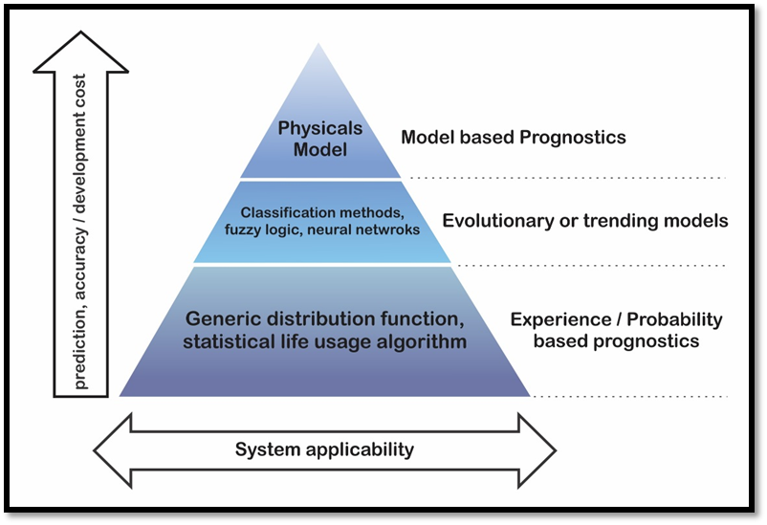Prognosis is a challenging task requiring exact, versatile and natural models to anticipate future health states. Various prognosis technique developed for the detection and classification of developing system fault.

**Figure 2. 2 Prognosis based techniques comparison**

The main aim of the prognosis technique in health monitoring is to provide an accurate and compact representation of multiple combination of gathered physiological signal from human body and implies the ability to detect or predict a future health condition of the patient. Figure 2.2 shows the comparison of the different prognosis technique.

#### 2.1.4.1 Model based prognostics:

Model based models can also be termed as physical based models when relatively precise mathematical models developed from the first principle of failure mode of system [Liang Tang et al. 2010]. Models can be categorized as quantitative or qualitative. These two approaches can be differentiated with the functional relationship with the system through mathematical modeling if it is designed than considered as a quantitative measures. On the other hand if system relates with functional dimensions for different units of developed system than it known as qualitative approach for models. These approaches are mainly analytical redundancy based approaches. The models can be analyzed by calculating inputs and outputs if it is possible than the system contains analytical redundancy. In other words it can be explained as to utilize redundancy of system it can be done by comparison of output for real process and model designed for the process. Model based approach provides the solution for predict or determine parameters directly from model designed. It also allows to include physical parameters to include in the account of system model.

#### 2.1.4.2 Experience/Probability based prognostics:

In this kind of prognostics no need to give more data as inputs because it has very long history of data available and based on that prediction will be easier as compared to other approaches. The history of database includes production based data, health rate data, statistics of different situations etc. For experience based approach probability density function (PDF) used to determine the probability and accuracy of the expected results based on datasets available. Some commonly used distributed functions are normal, weibull and exponential distribution

#### 2.1.4.3 Evolutionary models for prognostics:

The evolutionary models can also be termed as Data driven approaches which will mainly rely on the assumptions. It includes different logics, classifications and data neural network for the analysis. Based on mathematical and learning techniques from the theory of pattern recognition the data driven approach can be classified. Mainly advantage of this model is that it is capable of converting large amount of data with noise to smaller validated data which can be utilized for the prediction of future results. On another side it has disadvantage of dependency on the data as qualitative or quantitative measure. Because data plays a key role to get exact and reliable prognostics output.

### 2.1.5 Internet of Things (IoT)

All devices are connected to one another devices with various smart technologies to create worldwide ubiquitous network called Internet of Thing (IoT). IoT has abundant applications in healthcare, from remote monitoring to smart sensors and medical device integration. IoT is global system that could ultimately comprise more number of devices and applications as shown in figure 2.3, like sensors, actuators, health monitoring devices, diagnostics gadgets etc. to enhance the living life of patients with minor or major diseases. It is applied to enable the healthcare monitoring system via wired or wireless communication network and supported by cloud computing.

IoT can improve access and control all kind of interconnection of devices with patient healthcare. In health monitoring system most important role will take embedded technology to collecting, analyzing and transmitting stream of precise data for further analysis and review to doctors and take correct decision for patient healthcare. The IoT-driven healthcare monitoring system to collecting the data record and analyze updated data streams faster and more accurately.

IoT can help person to take some action as any changes happened to their normal life. But on the other side it is very difficult for doctors or healthcare centers to monitor every person’s data and manage that data on the regular basis.

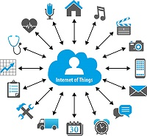To improve or reduce this complexity from the doctors and hospitals end, new approach can be considered to provide solution of occurred event as proposed in this dissertation topic.

**Figure 2. 3 IoT in Healthcare**

### 2.1.6 Biomedical application based sensor

**Table 2. 1 Biomedical Sensor and its application**

|  |  |  |  |  |  |  |
| --- | --- | --- | --- | --- | --- | --- |
| Type of Bio signal | Type of Sensor | Methodology | | Functionality/ Description | Applications | Measurement units |
| **Traditional method** | **Evolving method** |
| Electrocardio-gram (ECG) | Skin or chest electrodes | 12 Leads & ECG machine | Single Lead, Tri-Lead and Five Lead ECG machine | Digital waveforms shows continues changes in contraction and relaxation stages of the cardiac cycle | To identify or for the treatment of Cardiovascular diseases | Square box of will represent as horizontal side for time of 40 (mSec) and Vertical side for voltages of 0.1 (mV) |
| Blood pressure (Systolic and Diastolic) | Arm cuffed based monitor | Sphygmomanometer | Determination using red and infrared light going through throbbing blood in vascular tissue. | Force exerted by circulating blood on the blood vessels walls, particularly arteries | To identify or for the treatment of Cardiovascular diseases | Millimeters of Mercury (mmHg)  Or Kilopascal  (kPa)  1kPa = 7.50061683 mmHg |
| Oxygen saturation | Pulse Oximeter | Lancets, Test strips and Oximeter | The red LED measures deoxygenated hemoglobin and the infrared LED measures oxygenated hemoglobin | Indication of amount of oxygen that being carried in the blood of patient or indicates the oxygenation situations | For the disease related to oxygenation problems like, Asthma | Millimeters of Mercury (mmHg) |
| Heart rate | Skin electrodes | Stethoscope | Acoustic Sensors such as pulse Oximeter | Gives frequency of cardiac cycle | Helpful to detect heart attack, heart failure, stroke etc. | Bits per minute (bpm) mmHg |
| Body temperature | NA | Thermometer (mercury based) | Infrared based non-touch digital thermometer | Provides the ability of body to generate and release heat | To identify normal diseases related to body temperature like, fever | Celsius (°C) |
| Blood Glucose | Glucose meters | Lancets, Test strip based | Based on thermal emission spectroscopy | Measures amount of glucose in blood includes energy, level of sugar etc. | To determine the Diabetes and patient’s situation | milligrams per deciliter (mg/dL) or mill moles per liter (mmol/L)  0.06 mmol/L = 1 mg/dL |
| Perspiration or skin conductivity | Galvanic skin response | NA | Electrical conductivity of skin | Associated with the activity of skin glands | Hydration of skin can be determine | micro Siemens  (µS) |

### 2.1.7 Body monitoring systems:

#### 2.1.7.1 Patient monitoring systems to ensure security

Security is a major factor for any patient health monitoring systems. It is required to provide security for the data acquired from the person’s body status using sensors networks. To ensure the security to patient health monitoring system, recently used technology can be considered as Cipher text Policy Attribute Based Encryption (CP-ABE) scheme. For this scheme the data of patient’s health will get encrypted and decrypted while storing to server database. Therefore only authorized and accessible person will get the decrypted data after verification [SujiPramila R, 2013].

#### 2.1.7.2 Health monitoring using WSN:

Wireless Sensor Network (WSN) can be used to monitor the patient’s health in home. The network consists of different sensors which can distribute the resources and can collect the data of sensors and transfer that to hospitals. Infrared (IR) sensor based system can be installed in home to collect motion activity data of the patient. Different sensor nodes will get connected with hospital server for data received from the patient’s WSN in their home. Support Vector Data Description (SVDD) method behavior pattern classification algorithm used to differentiate the patient condition or behavior [SujiPramila R, 2013]. The collected data will get transmitted to hospital through internet and analyzed to detect diseases based on the readings.

#### 2.1.7.3 Patient monitoring with the help of mobile phones:

In patient health monitoring system, mobile phone plays more important role to transmit and receive the patient data. Body sensor network (BSN) implanted in clothes which collects the vital signal and transmits to the central hub at hospital servers. Communication done between central node and mobile phone via Bluetooth link. In addition to the system with mobile phone it has also functionalized with security and authentication parameters by using AES encryption algorithm and SHA for authentication of patients. Systems also developed with smart phones to improve the analysis of health conditions.

#### 2.1.7.4 Patient monitoring using Bluetooth enabled device:

Bluetooth enabled devices also used for some systems to detect the human diseases. In this type of systems every room in home equipped with one access point as Bluetooth has limitation with its range less than 10 meters. At the every access point it will get connected with the local database to store the measured data. Bluetooth communication is not as fast as in mobile phones and also it is not capable to cover more number of devices at a time. So it can be considered as another disadvantage for the system addition to the range issue. Systems developed for the analysis of Alzheimer disease based on movements and location of particulars will get sent to the hospital database for further analysis.

#### 2.1.7.5 Health Monitoring Using Body Sensors:

Body sensors which are wearable forms a network called Body Area Network (BAN). Wearable sensor based health monitoring system used two module patient home and hospital. In this type of system the BAN will collect the data of patient’s health and continuously sending that to central unit or controller. Technology used to transmit physiological signal data from sensor to central node will be wireless like, Bluetooth, Zigbee, Wi-Fi etc. At central node the vital signal converted from analog to digital form then transmit to the hospital server. At hospital end the received data will get stored and analyzed to identify any abnormalities [SujiPramila R, 2013].

### 2.1.8 Wireless Technology:

#### 2.1.8.1 Wireless Fidelity (Wi-Fi):

Generally, wireless Fidelity (Wi-Fi) is confirmed by IEEE 802.11 standard. Wi-Fi refers to Wireless Local Area Network (WLAN) by providing wireless connectivity.it is supports the two configuration mode; IEEE 802.11 and HiperLan and supported configuration mode is adhoc mode infrastructure mode. The communication of the Wi-Fi protocol depends on 2 conditions called access points to client source or from client-client form of communication. There are several standard available in Wi-Fi technology.

* 802.11: it is providing 1 or 2 Mbps transmission in 2.4 GHz frequency band using either frequency hopping spread spectrum (FHSS) or direct sequence spread spectrum (DSSS).
* 802.11b: it is provide an extension of 11 Mbps transmission in 2.4 GHz.it is supports DSSS only.
* 802.11a: it is provide up to 54 Mbps in 5 GHz using orthogonal frequency division multiplexing (OFDM).
* 802.11n: it is a modification to physical and MAC layer to provide 100 Mb/s in 5 GHz band with MIMO technology.

In addition, 802.11WG are defined for inter access point protocol and 802.11i version of MAC layer is enhance for security purpose.

#### 2.1.8.2 WIMAX:

Worldwide Interoperability for Microwave Access (WiMAX) IEEE 802.16 technique mainly used for long distance internet access with wirelessly and broadband at high speed data transmission. WIMAX technology provide internet accessibility up to 30 to 50 kilometer with 40 Mbit/s. it is most be4neficial for long distance compare to other technology at low cost of network expansion and also provide a portable mobile broadband connectivity.

#### 2.1.8.3 Bluetooth Technology:

Bluetooth wireless technology is designed for data communication as short range distance of connectivity in personal area network (PSN). The Bluetooth can be used in transmitting and receiving the information with only one device at any given time. It is mostly connected with the PC and mobile industry. Bluetooth technology is provide 10 meter wireless connection, where communicating devices are integrated nearby such as a home application similar to IrDA protocol and radio frequency technology (RF) in 2.5 GHz. In case of increase the transmission power we will extend the range up to 100 meter and line-of-sight is required for wireless communication. Bluetooth provides fast and secure access wireless connectivity.

#### 2.1.8.4 GSM technology:

In wireless communication, the global system for mobile (GSM) technology is deployed as second generation of wireless cellular system and helps to increasing the data transmission. GSM uses a Gaussian Minimum Shift Keying (GMSK) modulation method. It is a combination of TDMA and FDMA scheme. In this process, FDMA parts is divide total 25 MHz bandwidth of the frequency band in different slot into 124 carrier frequencies of 200 kHz bandwidth. Transmission rate of the GSM technique is 22.8 kBps and total symbol rate is 1 bit per symbol.in Frequency band of GSM, uplink frequency range is 933 – 960 MHz and downlink frequency band is 890 - 915 MHz In digital system, GSM transmit the data over the air is 270 kBps. Some technical property of GSM technology is shown in below table.

**Table 2. 2 Technical properties of GSM** (**Gu, G., 2010)**

|  |  |  |  |  |
| --- | --- | --- | --- | --- |
| **Property** | **Region** | **Forward**  **Band** | **Reverse**  **Band** | **Bandwidth** |
| **GSM** | Europe | 935-  960MHz | 890 - 915MHz | 50MHz |
| **Property** | **Multiple**  **Access** | **Channel**  **Spacing** | **Frame**  **Period** | **Cell Radius** |
| **GSM** | TDMA/FD  MA | 200KMz | 4.6 ms | 1-5 miles |
| **Property** | **Duplexing** | **Channel**  **Bit Rate** | Voice Bitrate | **Modulation** |
| **GSM** | FDD | 271 KBps | 13 KBps | GMSK |
| **Property** | **Mobile**  **Avg. Pwr** | **No. of**  **channels** | - | - |
| **GSM** | 0.25-2.5 W | 124(8user/  cha.) | - | - |

#### 2.1.8.5 ZigBee:

ZigBee wireless communication technology is widely used in transceiver in wireless sensor network. ZigBee is defined by IEEE standard “IEEE 802.15.4’ and it is high level transmission protocol. The characteristic of ZigBee module is short distance communication, low cost, low power dissipation, low data rate. ZigBee protocol has 2.5 GHz frequency band and it support the UART protocol and SPI protocol. ZigBee network can supported 653356 devices within up to 10-100 m range and defined data rate is 250 kBit/s.

### 2.1.9 Time Series Analysis Model:

The time series analysis is inspired by assumption of correlation between current value and past value and it is depended upon the adjacent point in time domain and exposed by considering experiment of real time data taken from different domains of area. Time series can be defined as a collection of random variables indexed according to the order they are obtained in time [].

#### 2.1.9.1 Linear regression:

In time series analyst linear regression is dependent upon the assuming time series output.it is prejudiced by collection of possible input ${ x}_{t}$, where t=1,…,n and independent series like $z_{t1}$; $z_{t2}$;…; $z_{tq}$, where, concerns inputs are fixed or unknown. The expression of the linear model is, ${ x}_{t}$ = $β_{1}z_{t1}$ + $β_{2}z_{t2}$ +……..+ $β_{q}z_{tq}$ + $w_{t}$ here, $β_{1}, β_{2},…, β_{q}$ are unknown fixed regression coefficients, and $w_{t}$ is random noise error.

#### 2.1.9.2 Smoothing in time series analysis:

This method is useful to discovering a characteristic of time series, for example long term tendency and seasonal component. If $x_{t}$ represents the observations, then

$m_{t}$ = $\sum_{j=-k}^{k}{{a_{j}x}_{t-j}}$

Where, $a_{j}$ = $a_{-j}$ $≥$ 0 and $\sum_{j=-k}^{k}{a_{j}}$ = 1 is a symmetric moving average of the data.

#### 2.1.9.3 Autoregressive (AR) model:

The AR (p) model uses a p lag variables which can be written as,

$Y_{t}$ = c + $\sum_{i=1}^{p}{∅_{i}}Y_{t-i}$ + $ϵ_{t}$

Where, $∅_{i}$ is constant, $ϵ_{t}$ is the error term at time t.

This model applied where the information used to predict the value of some benefit is based on the prior value of the asset in earlier time period from the data set.

#### 2.1.9.4 Moving Average models:

The MA (q) model uses q lag error term which can be written as,

$Y_{t}$ = d + $\sum_{j=1}^{p}{θ_{i}}Y_{t-j}$ + $ϵ_{t}$

Where, $θ$ is the coefficient and $ϵ$ is completely unknown.

#### 2.1.9.5 Autoregressive integrated moving average (ARIMA) model:

Classical regression An [ARIMA model](https://en.wikipedia.org/wiki/Autoregressive_integrated_moving_average) is a class of statistical models for analyzing and skillful forecasting time series data. An ARIMA model is helps to motivate the need to confirm the assumptions of the model in the raw observations and in the residual errors of forecasts from the model.

ARIMA acronym is descriptive based on key aspect of the model.

* **AR: Auto regression**. The auto regression model that is uses the dependent relation between an observation and some number of legged observation.
* **I**: **integrated.** When subtracting an observation from previous observation time step i.e. differencing of raw observation.
* **MA**: **moving average.** A model that uses the dependency between an observation and a residual error from a moving average model applied to the lagged observation.

In ARIMA model each component is specified as a parameter. The standard notation is used to ARIMA (p, d, q) and model has p auto regressive term and q moving average terms with d is degree of differencing. Where, the parameter are substitute with integer values. The parameter are defined as:

* **P:** the number of lag observation included model, called as lag order.
* **d:** The number of times that the raw observations are differenced, also called the degree of differencing**.**
* **q:** The size of the moving average window, also called the order of moving average.

The expression of an ARIMA model is in terms of,

$$Y_{t}^{(d)} = c+\sum_{i=1}^{p}{∅_{i}}Y_{t-i}+\sum_{j=1}^{q}{θ_{i}}ϵ_{t-j}$$

An ARIMA model is extremely used in statistic and time series econometrics application.

#### 2.1.9.6 ARCH/GARCH models:

In every situation, the question arise whether applied model is suitable to our data or not. Whether its prediction are valid or not. ARCH/GARCH variance of model is describe to rolling standard deviation. The mathematical expression can be written as,

$σ_{ut+1}= \frac{1}{n}\sum_{i=0}^{n}{σ_{ut-i}}$

This is more realistic because 1) Assuming equal weights seems inaccurate since we presume that more recent observations are more likely to be more relevant, and 2) Re-stricting our weights only to some finite number of observations is not ideal[Bryant, 2014].

The autoregressive conditionally heterskedastic model (ARCH) model of order m can be written as:

$$u_{t}^{2}=c+ \sum_{i=1}^{m}{α_{i}u_{t-i}^{2}}+ w_{t}$$

The generalization of ARMA to ARIMA – Generalized autoregressive conditionally heterskedastic (GARCH) is uses that the greatest predictor of variance in the next time period is given by a weighted average of the long run average variance.

## 2.2 Literature Review

This section explicates the journals and technical papers referred briefly and it gives summary of all literature papers referred.

### 2.2.1 Overview of Papers and Journals Referred

**PATIENT HEALTH MONITORING SYSTEM (PHMS) USING IOT DEVICES [Aruna Devi.S,** **Godfrey Winster.S,** **Sasikumar.S, 2016]**

This paper is focused on develop the Patient Health Monitoring System (PHMS) using IOT devices is proposed to collect the obligatory parameters like temperature, blood pressure, sugar level, pulse rate and evaluate by the mobile application. Data acquired by the IOT device. PHMS notifies the patient with probable precautionary measures and recommended medical care in case of critical situation. Bluetooth technology and Wireless sensor network methodology used for communicate between patient`s Body Area Network (BAN) and server database. System accumulate the data from the IOT device and update in database to server at every sixty second, which is compare with normal value table to evaluate the patient status. In future we can add more feature to mobile application like linking with the ambulance Services, leading doctor's list and their specialties’, hospitals and their special facilities etc.

**Health Monitoring and Management Using Internet-of-Things (IoT) Sensing with Cloud-based Processing: Opportunities and Challenges [Moeen Hassanalieragh, Alex Page, Tolga Soyata, Gaurav Sharma, Mehmet Aktas, Gonzalo Mateos, Burak Kantarci, Silvana Andreescu, 2015]**

This paper is focus on the opportunities and challenges for IOT in recognizing proposed vision for the better future of health care. Remote health monitoring system based on wearable sensor. System architecture partitioning into Data Acquisition, Data Transmission and Cloud processing. The system mainly divided into for fundamental element acquisition, analytics and visualization. Data Acquisition and Sensing is used for Physiological data is obtained by wearable device that combine small sensor capable of measuring the different parameter and a communication platform used for transmitting the measured data. Using machine learning algorithms data analytics can probably identify correlation between sensor observations and clinical diagnoses. Different methodologies of Visualization is dependent upon the data inferred from the IOT sensor device.

**IoT Based Health Monitoring System by Using Raspberry Pi and ECG Signal [Megha Koshti1, Prof. Dr. Sanjay Ganorkar, Savitribai Phule, 2016]**

In this paper, research is mainly focused on monitoring system which monitor heart pulse of a patient. Implement Heart rate detection algorithm based on continuous wavelet which is designed for robust against the source of noise and interference present in acquiring ECG signal. Nerve voltage of patient`s heart pulse monitoring recorded by skin electrodes and then amplifies the signal and filter the noise. Afterwards signal transmitted to arduino.it will convert analog voltage to digital and stored in EEPROM of arduino. The digital value stored in EEPROM will be sent to pc through RS232 serial cable and opened in matlab. Using SSL algorithm transmitting private data via internet. Body temperature and accelerometer value show in embedded web server with SSL Encryption technique. Encryption method used for protection of embedded web server with encrypted password.

**Building an IoT-aware healthcare monitoring system [Freddy Jiménez and Romina Torres, 2015]**

This paper is focused to improve elderly person`s quality of life using IOT and build an ad-hoc extensible healthcare monitoring system using low cost wireless sensors (during run time) and proposed IOT technology by way of communication platform which alert in real time patients` relatives and doctors.in this prototype data acquired from the wearable sensor and transmit to the cloud. For night-care using UHF (ultrahigh frequency) RFID (radio frequency identification) technology we can repeatedly monitoring state of elderly patients at night and tracking the location by wearable ambient tag. IOT three tire architecture used a Bluetooth-enabled wireless body area network that attach sensor nodes to a collector, which aims was to measurement to gateway through a Zigbee model. Gateway convert sensor data to XMPP (Extensible Messaging and Presence Protocol) and data sent to a node for real time analysis**.**

**Health Parameter Measurement Using Internet of Things [Ms.Priti Satpute, Ms.Sneha Sahani, Ms.Amruta Suravase, Ms.Pooja Thombare, Prof.Jayshree Mahajan, Prof.Rahul V. Chavan6, 2016]**

In this paper, research is essentially focus on design a system to monitoring and determine the physiological data of patient. Mobile device support the wireless healthcare monitoring and it can be give patients` condition details. System also able to send information through text message and email.in critical situation system detect the sudden change in heart beat rate and body temperature and automatically alert to patient position by IOT and shows patients` status over the internet. Scalability and accuracy of the system has been tested in field. using GSM technology device can continuous access to person`s healthcare data via wireless communication and alert to the doctor. Wi-Fi protocol used for transmitting and receiving the information. ZIgbee based wearable health monitoring system gives real time data of patient sending alarming message to healthcare clinic.

**Sensing and Supervising through IOT [Ashwini Kumar Jha, 2016]**

This paper is focused on the human healthcare. Cochlear implant and pacemakers like IOT live capable device which can be stitched or implanted in to the human body. It will sense and transmit the data to concentrator or any hand held device like mobile. Treasure trove data will be sent to the cloud database for analysis. Analyzed data continuously supplied to the clinic display unit. Physicians able to take decision and suggest appropriate action for diseases solution. Data acquisition, data transmission, cloud processing different methodologies used for proposed monitoring system. IOT architecture can be improve energy efficiency adaptively of sensor based system. Bluetooth low energy wireless communication protocol used for low power short range communication. Using Data analytics machine learning algorithm can be establish connection between sensor observation and medical diagnostics. Erudite classification and deterioration technologies used for current data to update physician`s up-to-date prognosis.

**Smart Real-Time Healthcare Monitoring and Tracking System using GSM/GPS Technologies [Kahtan Aziz, Saed Tarapiah, Salah Haj Ismail, Shadi Atalla, 2016]**

In this paper present work build an effective application for real time health monitoring and tracking. System track, trace and monitor patient. By provide medical services could be taking care of patient health. Data will be captured by different sensor and compare with configurable threshold value via microcontroller which is suggest specialized doctor for patient treatment. Using GSM technology measured data sent to doctor in emergency situation by short message service (SMS). GPS technology used for track the location of monitored patient position under observation .End to end smart health System design to monitoring the real time health parameter such as heartbeat and body temperature. System will be able to bridge gap between patient health change reasons and entities who response and take action in real time. Using wireless communication technologies results display into a smart mobile phone or computer.in future we can add more measurement parameter according to available sensor in market.

**Health Monitoring System Based on Wearable Sensors and Cloud Platform [Rasha Talal Hameed, Omar Abdulwahabe Mohamad, Nicolae Ţăpuş, 2016]**

This paper is focus on design a model for monitoring and checking the patient health condition. Sensor measure different parameter such as glucometer, airflow and patient position which are transferred via microcontroller by way of a gateway to cloud storage. Measured stored data can be accessible for analysis of various associations between measured parameters and patient`s status. For transmission information being used Zigbee protocol and wireless sensor network and GSM and web services for record the patient data. System gives minimum complexity and very portable for healthcare surveillance.

**A Proposed Architectural Model for Vital Sign Monitoring System [Vishakha Deshmukh, Sanjeev Wagh, 2015]**

This paper is focused on a portable vital sign monitoring system using GSM technology. Electrocardiogram, Blood Pressure and Temperature Measured of vital sign and retrieved information into functional information for classification and prediction of patient condition. patient`s history about health information kept in database. System architecture divided in three layers that is sensing, communication and presentation. Algorithm used for data analysis included with data mining technique i.e. decision tree with C4.5 and associate rule techniques. System will collect different sensor value compared with already set value in system. Afterwards system will notifies there is risk or not. According to results we can predict and treat patients.in future we can import more new sensor to measure blood sample to detect diabetes and blood tumor.

**Smart e-Health Gateway: Bringing Intelligence to Internet-of-Things Based Ubiquitous Healthcare Systems [Amir-Mohammad Rahmani, Nanda Kumar Thanigaivelan, Tuan Nguyen Gia, Jose Granados, Behailu Negash, Pasi Liljeberg, and Hannu Tenhunen, 2015]**

In this paper the author focused on gateways to establish communication between nodes and internet system. They have exploited strategic position of gateways for the developed system to provide advance level services like, locally storage data, processing of real time locally saved data, data mining algorithm techniques for embedded systems etc. Smart e-Health gateway system (SeHG) developed as a solution of already exist system issues or challenges like, reliability, scalability and energy efficiency etc. They developed and tested SeHG system for one case study i.e. UT-GATE with advance level features. The system developed with Wireless network created for collection of patient’s body parameters using sensor network created known as Body Area Network (BAN). The architecture designed such that it will receive the data from BAN through WAN and transmit that data for further data processing which includes some analysis on the fetched information i.e. Big Data analysis. The developed system tested with considered case study proposed with solution to existed challenges in ubiquitous healthcare system and provides efficient results at the end for designed SeHG. Only diagnostic performance discussed from the available data can be considered as a loophole in the present study.

**Smartphone-based personalized blood glucose prediction: [Juan Li∗, Chandima Fernando, 2016]**

In this paper, research is mainly focused on identify diabetes prediction mechanism that patient`s data collected by smartphone and then patient`s data send to drive for predict blood glucose level. This proposed model as mobile application is mainly used for combine population data and captures patient`s similarities and finally personalized blood glucose level. Based on the daily activity patterns and historical population data the Data-centric predictive model used to predict the patient`s BG level. Based on the personal history three stage time-series regression model, pooled panel data regression model and a pre-clustered personalized regression model available for prediction. Research work move away to synthesis of population and patient-based analysis and prediction. The result could be improve the prediction accuracy and remove medication the problem of sparse data in existing prediction methodology.

**A Physiological Time Series Dynamics-Based Approach to Patient Monitoring and Outcome Prediction: [Li-wei H. Lehman, Ryan P. Adams, Louis Mayaud, George B. Moody, Atul Malhotra, Roger G. Mark,and Shamim Nemati, 2015]**

This paper is focused on heart rate (HR) and blood pressure (BP) like physical variable of vital signs time series dynamics, analytically to cultured and recognize using switching vector autoregressive basis time series model which are probably frequent within the identical patient and may be shared through the whole legion. dynamic behavior shows the patient`s physiological state. Based on the orthostatic stress study of HR and BP with body position, time series of the cardiovascular system could be simulate. From the survey of intensive care unit (ICU) of 450 patient from the MIMIC II database based on the HR and BP dynamics. If combine the dynamics of BP and SAPS-I or APACHE-III will give more precise duty of patient survival in the hospital. Results advise that the revealed changing aspects of the vital sign time series may contain extra accurate prognostic value than the baseline vision of measures and possibly could be used as an autonomous predictor of results in the ICU.

**Time-Series Analysis of Continuously Monitored Blood Glucose:The Impacts of Geographic and Daily Lifestyle Factors: [Sean T. Doherty and Stephen P. Greaves, 2015]**

Diabetes is identified to be related with ecological, behavioral and lifestyle factor. However, the tangible effects of these factor on blood glucose (BG) variation through the day have endured comparatively unknown. Blood glucose monitoring association with the human action tracking technologies with new opportunity for exploring in a realistic .in this paper researcher surveyed 40 patients of the diabetes report with constantly BG monitoring, food/medicine ingestion, location of patents followed by the global positioning system (GPS) in excess of 4 days. Standard linear regression and more disaggregated time series analysis using autoregressive integrated moving average (ARIMA) are used to investigate patient BG variation during the days. The ARIMA models discovered an inclusive variety of BG connecting factors correlated to precise action types, positions, location and travel modes. Based on the analytical method, ARIMA model predict a dependent variable`s present based on its past values plus values of other explanatory variables [].We would suggest that maps of BG spatial variation or an interactive messaging system could provide new tools to engage patients and highlight potential risk factors [sean t, 2015].

**Wireless Health Monitoring System for Patients: [Salman Ahmed, Sabrin Millat, MD. Aymanur Rahman, Sayeda Naeyna Alam, Md. Saniat Rahman Zishan, 2015]**

The system is designed for healthcare department with the presence of telecommunication technique. Device will be able to transmitting the patient`s vital sign data set by remote device wirelessly to doctor or physician and analyze by expert. The system is mainly focus on the improving the trouble which is met by medical care taker in monitoring of manifold patients concurrently. The system will empower them to watch patients without being physically present at their bedside in hospital or their home. Vital sign parameter such as body temperature, heart rate, and electrocardiography are transporting through Bluetooth technology. adopting wire technique useful for patient`s better care with less hardship. With the help of other wireless technology we can improve the accuracy of system. System can be integrating with the GSM technology, cover a long distance.

**IoT Based Patient Health Monitoring System Using LabVIEW and Wireless Sensor Network: [ Abasi Julius, Zhang Jian-Min, 2015]**

Patient health monitoring is the one of the field that is quickly developing with the advancement of numerous specialists have escorted different design for health observing framework according to the technological improvement. In this paper researcher developed IOT based health monitoring system using lab view and wireless sensor network (WSN). System will be capable to take physiological parameter send on web server wirelessly by Xbees for visualized on GUI created on lab view. Specialists are able to operate the web server from the long distance through internet connectivity and control and monitoring the patient`s health. This designed system are able to detect the abnormality of cardiac function, measure the patient`s temperature immediately, measure the heart rate after that system can be analyze the detect condition of signal if it is normal or abnormal and notifying the doctor by messaging. System can be extend by integrating more number of sensor so that will observe the vital parameter such as blood glucose level, blood pressure etc.

**Implementation of Portable Device for Real Time Bio Signal Analysis using LabVIEW: [R.Selvarasu and S.Gavaskar, 2015]**

The system prototype is designed to measure the physiological signal of human body and detected signal value transmit to the remote location via SMS message for analyzed. Detected bio signal is in form of analog signal, which is produce by sum of electric potential difference diagonally specialize tissue, organ, or nervous system. Pulse code modulation technique used for detect the analog ECG signal with ag/agcl electrode.

The monitoring of set up of the distinct electrical depolarization and repolarization pattern of ECG signal is an important to elevate the living condition of patients and diagnose the heart correlated disputes such as cardiac disorder. Any change in the heart rate pattern, rhythm, and any morphological signal, is sign of cardiac arrhythmia which is analyzed by the experts of medical domain. For analyzed high quality signal from a public cardiac database, artificial neural network is used. For detection and classification of ECG waveform, wavelet methodology is used.

In Automatic analyzing computing method, ECG signal is help to detect time interval between R-R intervals, QRS interval, ST elevation of ECG signal which provide the information such as position and magnitude of PR interval, segment interval of QT level and it is mainly useful for diagnose a diseases. Portable device is integrated with the IR sensor, ECG processing unit, crystal oscillator, Thermistor, PIC Microcontroller and linkage between the micro controller and cell phone. Finally, developed system is user friendly portable device and it is reduce complexity of the users.

**Hemodynamic Monitoring Using Switching Autoregressive Dynamics of Multivariate Vital Sign Time Series: [Li-wei H. LehmanI, Shamim Nemati2, Roger G. Markl, 2015]**

The research paper mainly focused on hemodynamic monitoring of ICU patient by study variation and link between the heart rate (HR) and blood pressure (BP) which provide prognostic value for future mortality risk of ICU patients. Switching autoregressive (SVAR) dynamics used for find the possibility of future mortality of ICU patients who receiving vasopressor treatment, also used originated vital sign at dormant state of autoregressive Hidden Markov Model (ARHMM) process for predict the outcomes, the study exploit data of 453 ICU patients from the MIMIC II waveform database. HR and mean arterial blood pressure monitoring and study gives the valuable information about the future health, other laboratory and body vital sign parameters along study with vasopressure treatment and other interventions can more accurately gives future mortality risk and health information of ICU patients.

### 2.2.2 Literature Summary

In this section the summary of all the journals and papers are represented in the form of table which is shown in Table 2.3.

**Table 2. 3 Literature summary for referred papers**

|  |  |  |  |  |  |  |  |  |
| --- | --- | --- | --- | --- | --- | --- | --- | --- |
| **Sr. No** | **Authors** | **Journal name & Year of Publication** | **Research Focus** | **Methods and Methodo-logies used** | **Research Findings** | **Conclusions drawn by authors** | **Limitations of Study** | **Critical Appraisal of the Published Work ( by the student)** |
| 1 | Aruna Devi.S, Godfrey Winster.S, and Sasikumar.S | International Journal of Computer Science & Engineering Technology (IJCSET), 2016 | Focused to develop the Patient Health Monitoring System (PHMS) using IoT devices is proposed to collect the required  parameters and evaluate the data obtained from the IoT devices | Wireless sensors network and Bluetooth technology used for communicate between patient’s body area network and server database | to overcome  serious problems the new Patient Health Monitoring System (PHMS) is proposed to monitor and evaluate the status  of each patient by the doctor even in their absence in hospital or near the patient | An efficient PHMS is developed to monitor the up to date status of the patient irrespective of the presence of  the doctor. The system is evaluated experimentally and collected the sample data of ten  patients to verify the status of patients. The doctor can monitor the progress of patients' health now and then to  advise them about their health | Each parameter requires different device and it increase the system size | New system with small size and more parameters can be introduced for replacement, The system can be extended by adding more features to the mobile application like linking the ambulance  services, leading doctor's list and their specialties, hospitals and their special facilities etc |
| 2 | Hassanalieragh, M., Page, A., Soyata, T., Sharma, G., Aktas, M., Mateos, G., Kantarci, B. and Andreescu, S. | International Conference on Services Computing, 2015 | Research mainly focused on Opportunities and Challenges or IoT in realizing proposed vision for the better future of health care | Data acquisition, Data transmission, Cloud processing | highlighted several of the challenges in sensing, analytics, and  visualization that need to be addressed before systems can be  designed for seamless integration into clinical practice | Wearable  sensors, particularly those equipped with IoT intelligence,  offer attractive options for enabling observation and recording  of data in home and work environments, over much longer  durations than are currently done at office and laboratory visits | Proposed study only focuses on the opportunity and challenges for IoT environment in health care system no any system designed to overcome challenges | Can add some hardware systems for analysis on recorded data of person’s health |
| 3 | Megha Koshti, and Prof.  Dr.Sanjay Ganorkar | International Journal of Innovative Research in Science,  Engineering and Technology, 2016 | Mainly focused to implement a monitoring system which monitors the heart pulse of a patient | heart rate detection  algorithm based on the continuous wavelet transform, SSL encryption used | System designed through wireless sensors network and reduced the complexity and size for existed systems | Successfully developed a system for patient monitoring and results shown the system achieved first objective | Only single functionality included i.e. for heart pulses | More functionalities can be added with the developed system |
| 4 | Jiménz, F. and Torres, R | International Journal on Recent and innovation trends in computing and communication,2015 | Mainly focused to improve elderly people’s quality of life using IoT technology | Extensible Messaging and Presence Protocol (XMPP) for real time communication, Smartphone as gateway, Bluetooth sensor for collection of data | final users are able to create rules’ alerts using both the  previous and recent added sensors without stop the system | presented a prototype implementing  an IoT-aware healthcare-monitoring system, which should  reduce the cost of healthcare and should decrease the need of  specialized personnel because patients’ monitoring care may be  automatically performed at home | No scalability testing done yet for new sensors or equipment | Scalability of the system can be improve by implementing new algorithms for gateway medium |
| 5 | Ms.Pri Satpue, Ms.Sneha Sahani, Ms.Amruta Suravase, Ms.Pooja Thombare, Prof.Jayshree Mahajan, Prof.Rahul V. Chavan | International Research Journal of Engineering and Technology (IRJET), 2016 | Focus on system designed to monitor and determine physiological data of patients and also give the detail of patients` body condition | GSM technology and Wi-Fi protocol used for provide continuous access to person healthcare data and alert to doctor | Highlighted challenges like  Sensing, analytics and visualizations need to be address before system can be design integrate in clinic | Wearable sensor equipped with IOT intelligence for enabling observation and recording data in home and work environment collection of data analyzed and presented to physicians in easy to assimilate. | Proposed study only focus on challenges, no any IOT intelligence system available to overcome challenges. | Can add some hardware systems for analysis on recorded data of person’s health. |
| 6 | Ashwii Kumar Jha | International Journal of Computer Applications, 2016 | Focus on human health, IOT would require to have live capable devices which can be stitched or implanted in human body , devices such as cochlear implant and pacemakers will sense | Data acquisition, Data transmission, Cloud processing | IOT based device uniquely addressed and identifiable patient`s medical condition at any time anywhere through internet and give accurate diagnosis result over a long period of time. Highlight opportunity and challenges for IOT in future health care in real time | Wearable sensors, mainly prepared with IoT acumen, proposal attractive options for enabling observation and recording of data in home and work environments, over much longer durations | Proposed study gives only brief idea about the system but does not give any particular techniques and also not mention any data storage method or technique | Scalability and accuracy of the system can be improve by implementing new algorithms for gateway medium |
| 7 | Kahtan Aziz, Saed Tarapiah, Salah Haj Ismail, Shadi Atalla | International Conference on Big Data and Smart City, 2016 | Focus to build an effective application for real time health monitoring and tracking and taking care of their health | GPS, GSM Web technology used for global communication | System can be designed to analyze, test and validate several experiment and results shown in simulation software | Grantee to improve the quality of health services and to reduce the total cost in healthcare by avoiding unnecessary hospitalizations and ensuring that those who need urgent care get it sooner. | Proposed system only measure the heart beat and body temperature | Can add some other vital factor measurement according to available sensor in market |
| 8 | Rasha Talal Hameed, Omar Abdulwahabe Mohamad, Nicolae Ţăpuş | International Conference on System Theory, Control and Computing (ICSTCC), October 13-15, Sinaia, Romania, 2016 | Focus on designed an experimental model for monitoring and checking the health condition of patients. | Zigbee protocol, wireless sensor network, GSM, Web services technique used for transmitting and record the patient data | System designed based on cloud platform for observing a patient who suffers from the specific disease. | designed system gives minimum  complexity and very portable for healthcare observing of the  patient | No accuracy and scalability test done yet for new sensor and equipment. Only simulation is done | More features can be add in mobile application and functionality can be adding with the developed system |
| 9 | Vishakha Deshmukh, Sanjeev Wagh | IEEE ICCSP  Conference, 2015 | Focused on design implementation vital sign monitoring system is based on internet and wireless sensor network. | GPRS, GPS and Wireless sensor network technique used for communication. Data mining algorithm used for data analytics. | System is measure of vital sign and retrieved information into  usable knowledge for classification and prediction of patient  Condition. | Vital sign monitoring system is a challenging task, but it  Reduces the human effort and increases the result accuracy.  Applying Internet of things into Health Care systems would  Help to improve the effectiveness and efficiency of the health care organization's activity. | Proposed IOT intelligence system is not given any security for data extraction. | Can import more new sensor to measure blood sample to detect diabetes and blood tumor. |
| 10 | Amir-Mohammad Rahmani, Nanda Kumar Thanigaivelan, Tuan Nguyen Gia, Jose Granados, Behailu Negash, Pasi Liljeberg, and Hannu Tenhunen | IEEE Consumer Communications and Networking Conference (CCNC), 2015 | Focused  on gateways to establish communication between nodes and internet system | Wireless network and data mining algorithm technique used for data analysis and processing | (SeHG) developed as a solution of already exist system issues or challenges like, reliability, scalability and energy efficiency etc.  Developed system tested by UT-GATE with advance features | The developed system tested with solution to existed challenges in ubiquitous healthcare system and provides efficient results at the end for designed SeHG. | Present study only focus on diagnosis performance based on availabledata can be considered as a loophole. | Can be more functionality add in developed system for prognosis based health monitoring system. |
| 11 | Juan Li, Chandima Fernando | The Korean institute of communication and information sciences, 2016 | Focus on personalized diabetes mechanism using smart phone application | Time-series prediction model,Pooled-panel-data regression model,Pre-clustered personalized regression model | To overcome the data sparsity issue and obtain the estimate value also clustering offer reduce the required data for prediction | Personalized BG prediction model developed to predict the patient BG level accurately and automatically | Proposed system only focus on the single vital sign parameter | The system can be extended by adding more features to the mobile application like linking the ambulance  services, leading doctor's list and their specialties, hospitals and their special facilities etc |
| 12 | Li-wei H. Lehman | Ieee journal of biomedical and health information, 2015 | Research based on monitoring and future outcomes prediction of patient critical bed situation by using time series dynamics | switching vector autoregressive model of cohort time series, Cardiovascular Simulation with delay recruitment model of time series | Monitoring BP and HR of ICU patients and prediction of future health | Presented switching vector autoregressive framework helps to learn and identify ICU patient future tendency to survive at hospital | The study covers less number of patients, Delay of system is high | The system performance can be improved by using internet technology, it can be used For large scale, more resource for collecting and comparing health related data reduce delay of the system |
| 13 | Sean T. Doherty, Stephen P. Greaves | Hindawi Publishing Corporation Journal of Diabetes Research, 2015 | Effects of Geographical factor and daily lifestyle on BG | Linear regression,  autoregressive integrated moving average (ARIMA)time series model | To finding the different factors impact on variation of BG like geographical area food, daily activity etc | Beyond the traditional method the system measure BG based on GPS and various other factors which useful for future diagnosis | Proposed system only focus on study of data it not having any diagnosis or alert system | Diagnosis and prognosis can be added to the system also a sms based alert system can be implemented for alert the person when suddenly change the BG level |
| 14 | Salman Ahmed, Sabrin Millat, MD. Aymanur Rahman, Sayeda Naeyna Alam, Md. Saniat Rahman Zishan | IEEE international WIE conference on electrical and computer engineering, 2015 | Research deal with design a wireless system for observing the patient health | Hardware circuit used for measure body temperature, ECG and heart rate with Arduino uno board and bluetooth | Continuously monitoring patient health more efficiently and effectively with less number of doctors and nurses | Adopting wireless system for health monitoring is useful for patient better care with less hardship | Data packet loss at Aruino uno end, Bluetooth used for short range only | The system can be used for long distance by using IOT devices, other wireless technique can be used for accurate data accumulate |
| 15 | Abasi Julius , Zhang Jian-Min | International Journal of Science and Research (IJSR), 2015 | Focus on develop WSN based health monitoring system | WSN network using ZigBee,  Arduino Mega 2560, labVIEW | Incessant surveille patient health using WSN and get person health related data anywhere at a time by using internet | Patient monitoring system is very useful for health monitoring and give the solution of health related question easily | Diagnosis of disease has not been done, if number of WSN node increase system became heavily complex | The IOT based system can be more useful if introduce diagnosis and prognosis of disease |
| 16 | R.Selvarasu ,S.Gavaskar | Ciit International Journal of Wireless Communication, 2015 | To design mobile device for actual time body signal analysis | IR sensors, PIC Microcontroller, GSM module, LabVIEW | Analysis of ECG signal by using LabVIEW if suddenly changes occur reports the doctor through SMS | Actual time ECG analysis plays major role in healthcare system, person easily get first aid | Proposed Mobile device is too bulky, less accuracy, analysis history is not present for study | System can be more accurate by using IOT devices and different technique for measure the ECG, Internet with cloud storage function can be added to the system |
| 17 | Li-wei H. Lehman, Shamim Nemati, Roger G. Markl | IEEE international conference on Computing in Cardiology(CinC), 2015 | Research focus on monitoring patient hemodynamic by using vital sign time series analysis | Switching autoregressive (SVAR) model, autoregressive Hidden Markov (ARHMM) model , MIMIC II waveform database for utilize data | Research finding the scale success of interventions and help the healthcare team about future ICU care decisions | HR and mean arterial blood pressure reliably using for prediction of patients future health and healthcare | No Real time implementation done, patient bad condition alert system has not been introduced | Globally Alert system for Bad condition of patient can be implemented by using internet, other body signal parameters can be used for different disease also |

## 2.3 Problem Formulation

### 2.3.1 Identification of Research Gaps

* From the literature survey, it is evident that the developed systems just focus on monitoring and alert with no extended process with the generated data.
* Hence, the proposed dissertation work emphasis on a system which will able to monitor, collect, analyze the collected data for critical set conditions, and predict the time criticality.

### 2.3.2 Research questions the dissertation would like to address

# 3. Problem Statement

The chapter comprises of the title, aim, objectives and methodology of the Dissertation. The objectives of the project and the methods followed to achieve the identified objectives are listed.

## 3.1 Title

Design and Development of a Prognosis Based Body Monitoring and Reporting system

## 3.2 Aim

To design and develop of a prognosis based body monitoring and body diagnosis system which is the process of determining the patient`s diseases and notify to clinic health care about criticality of patient.

## 3.3 Project Objectives

Based on literature review, problem statement and aim of the project, objectives are identified and listed as below,

* To review existing literature on data mining, prognosis based techniques, Internet Of Things (IOT), Biomedical application based sensors, body monitoring systems, body diagnosis reporting system.
* To arrive at the requirements, identify the parameters to be employed and design specifications for body diagnosis based on literature survey
* To design the prognosis based body monitoring and reporting system based on the requirements and specifications
* To develop the software components for the prognosis based body monitoring and reporting system
* To select appropriate hardware and develop the hardware circuitry of the prognosis based body monitoring and reporting system
* To integrate the software and hardware and test the functionality
* To analyze the performance of the developed system

## 3.4 Methods and Methodology

**Table 3. 1 Methods and Methodology to achieve defined objectives**

|  |  |  |
| --- | --- | --- |
| **Objective No.** | **Statement of the Objective** | **Method/ Methodology** |
| 1 | To review existing literature on data mining, prognosis based techniques, Internet Of Things (IOT), Biomedical application based sensors, body monitoring systems, body diagnosis reporting system. | Literature review of previous work using books, journals and videos |
| 2 | To arrive at the requirements, identify the parameters to be employed and design specifications for body diagnosis based on literature survey | Based on the application and literature review design and functional specification is been arrived |
| 3 | To design the prognosis based body monitoring and reporting system based on the requirements and specifications | based on the requirements and specifications |
| 4 | To select appropriate hardware and develop the hardware circuitry of the prognosis based body monitoring and reporting system | Simulation setup designed in LabVIEW graphical coding software |
| 5 | To integrate simulated model and test the functionality | Integration of system for developed suitable test cases which can be used to perform testing |
| 6 | To analyze the performance of the developed system | Based on data collected and result of developed system analysis to be performed and outcomes to be obtained |

# 4. Design and Implementation

This chapter encompasses requirements analysis, design specifications, hardware and software requirements. Also it contains design and implementation stages like, block diagram, flow chart, and algorithms etc.

## 4.1 Requirement analysis

This section contains some details about functional and nonfunctional requirements of the system designed.

### 4.1.1 Functional Requirements

Body monitoring and reporting system can be designed after doing analysis of basic functional requirements for system, it can be given as listed below,

1. System should not interfere patient’s regular life style with its dimensions and design.
2. It should be reliable enough to provide solution and notification of criticality of patient’s health at any time.
3. It should quick to respond if critical situations will get occurred and should notify the related people for the event.
4. System should maintain the normal state of patient’s body by notifying the abnormality as it happened.
5. System should record and store the data as history of patient’s health on continuous basis to keep update of body parameter changes.
6. Should not behave inappropriately in the case of no such criticality issue actually occurred. So accuracy is must for this kind of case.
7. System should provide access to get healthcare data in case of any emergency occurs.
8. It should be light in weight and smaller in size to provide more compatibility to users.

### 4.1.2 Non-functional Requirements

1. Authorization provided for every time patient want to access the database of body monitoring healthcare system.
2. For security issues, patient can change their authentication details and also gets notified when attempts to change or entered wrong password.
3. System will provide logged off state if person is idle for more that threshold time.
4. System should have limit to handle the number of iterations for healthcare data collection.
5. User should get updates only for recently updated data for no criticality cases.

## 4.2 System Specifications

A personal health monitoring & diagnosis system can be very useful, though the creation of such a system requires good effort. Though this system is designed with patients in mind, it can be used by everybody who wants to keep track of their health condition. Anyone with proper credentials can access this system. This section comprises the specification about hardware and software requirements to design the health monitoring & diagnosis system.

### 4.2.1 Hardware requirements

Hardware requirements defines actual idea of how system will be more efficient and effective. As per the desired outcomes and required features in the system, hardware requirements are necessary to decide. In the case of this body monitoring and reporting system, prognostics plays an important role. To do analysis of such big datasets it requires more powerful but less expensive system processor. Based on some hardware controllers and processors comparisons, this section gives better idea of choosing an appropriate hardware. Some of the available hardware for system developed can be explained.

#### 4.2.1.1 Embedded boards

In market today so many system on chip devices available with different functionalities. Some of these hardware can be given as, Beagle bone, Raspberry Pi, Arduino, Microcontrollers etc. based on the system requirement to choose an appropriate hardware let’s consider comparison stages based on its features and specifications like processor speed, supported operating system and languages, memory space, USB etc. Table 4.1 shows the comparison of all these boards with its specifications.

**Table 4. 1 Embedded boards comparison**

|  |  |  |  |  |
| --- | --- | --- | --- | --- |
| **Platform** | **Arduino** | **Propeller** | **Beagle Board** | **Raspberry pi** |
| Variant | Uno | Propstick | Rev.C4 | Model-B |
| **Software** | | | | |
| Operating System | - | - | Android, Linux, Windows CE, RISC Os | Linux, RISC OS |
| Toolkit | Arduino IDE, Eclipse | Propeller/Spin | Eclipse, Android ADk, Scratchbox | OpenEmbedded, QEMU, Scratchbox, Eclipse |
| Programming language | Wiring based c++ | Spin, Propeller Assembly | Python, c, etc. | Python, c, Possibly BASIC |
| Architecture | 8 Bit | 32 Bit | 32 Bit | 32 Bit |
| **Hardware** | | | | |
| Processor | ATMEGA328 | P8X3A-M44 | TI DM3730(ARM) | BCM2835(ARM) |
| Speed | 16Mhz | 20kHz/12Mhz (internal)  4-8MHz (external) | 720Mhz | 700Mhz |
| RAM | 2 kB | 32kB | 256MB | 256MB |
| ROM | 32 kB | 32kB | 256MB Flash | SD |
| I/O(various protocol) | 14 | 32 | 22(on expansion order) | 8 |
| ADC | 6 | - | Internally used | Internally used |
| USB | - | - | 1 × 2.0 | 2 × 2.0 |
| Audio | - | - | Stereo In/Out | Stereo Out, In/USB Mic |
| Video | - | VGA, NTSC or PAL | DVI-D, S-Video | HDMI,NTSC or PAL |
| Misc. | Many shields available for capability | 8 Processor for parallel tasking | SD/MMC, RS-232, JTAG, USB, OTG, LCD | SD, 10/100 Ethernet, JTAG |
| COST | $29.95 | $49.99 | $199.95 | $35.00 |

* **Raspberry pi board:**

Raspberry pi is a small, powerful, cheap, efficient, flexible, hackable, completely customized and programmable minicomputer board. This credit size computer compatible with every platform for interfacing with many devices and software with in built WI-FI. Raspberry pi is operate same way as a PC.

The hardware chosen is Raspberry Pi board which is compatible with more than one programming languages like, C, C++, JAVA, Python etc. From the comparison of all these languages and their execution time, Python is more suitable language for this kind of system.

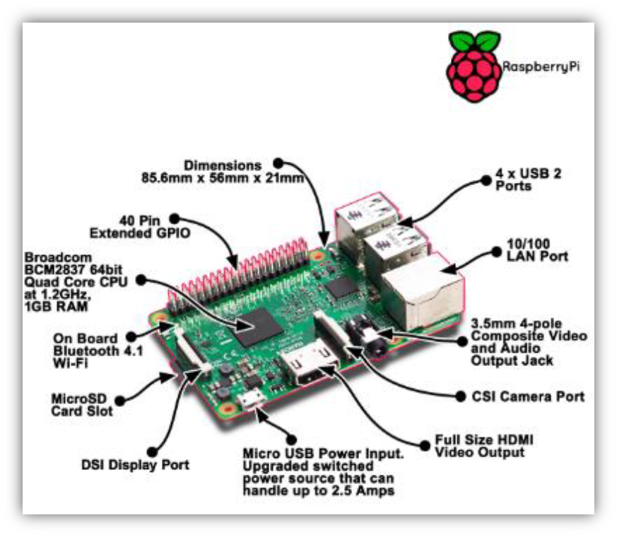Python has user friendly data structure and it takes much less time to development and it has no need of declaring types of arguments and variables. As it provides less coding and better execution output, it is relevant choice to design to get the data from thing speak channel and send it to LabVIEW for further analysis of the collected data.it will be send HTTP request to the thing speak channel using python code. Raspberry pi fetch the health statistic data from the thing speak channel and it will get stored in a text file on raspberry pi. Every time updated value will get stored in text file generated at raspberry pi side continuously.

**Figure 4. 1 Raspberry Pi 3 model B+ ()**

#### 4.2.1.2 Sensors

For developed system requirements, it is required to choose an suitable heartrate sensor for taking correct and accurate reading from patient`s body for predicting and diagnosis the patient`s health. In market research, there are many sensor available for measuring heartrate vital sign in health monitoring system.

* **Types of heart rate monitoring sensors**:

In clinical application heart rate monitor helps to identify patient`s diseases, patient`s health condition based on the heart rate of the patient.

1. **Heart rate monitor that is strapped to the chest:** this is the most accurate heart rate monitor by way of it very nearby patient heart. This types of sensors is very costly.
2. **Pulse type monitor:** in this type of monitoring system sensor sense the heart rate when a finger placed on it. In this type of system drawback is that it is not possible to obtain constant reading and they do not give the accurate and correct result all the time. For example, if figure are very cold then there is chance for giving a false reading.

* **Pulse sensor:**

For the develop system requirements, it is choose appropriate pulse sensor for taking heart rate reading for simulated system because it is very low cost than other sensor and also size is very small so it is compatible with the wearable sensor device. Pulse sensor is an open source hearate monitor sensor built to work with the NodeMCU v0.9.it utilizes periodic sampling of ADC value from the light intensity sensor, and signal filtering to detect the peak-to-peak length in data. The heart rate is measured from the finger tip of the patient. It can also measure from the softer part of the ear lobes [mohanraj T, 2017].

#### 4.2.1.3 IoT module:

**Figure 4. 2 Pulse sensor (T, M., 2017)**

IoT modules are useful to connect host CPU over SPI/SDIO/UART interface and it`s save CPU cost. It can directly integrating with the low footprint SDK and network stack on your CPU. We can easily interface with our product because it`s consume less power, small size and low cost module. Below table shows comparison of different IoT development modules.

**Table 4. 2 IoT Module boards comparison (blog.squix.org, 2015)**

|  |  |  |  |  |  |
| --- | --- | --- | --- | --- | --- |
|  | **NodeMCU V0.9** | **NodeMcu V1.0** | **Wemos D1 Mini** | **Wemos D1 R2** | **LoLin V3 NodeMcu Board** |
|  |  |  |  |  |  |
| Branded | NodeMCU | DOIT | Wemos | Wemos | LoLin |
| GPIO pins | 11 | 11 | 11 | 11 | 11 |
| ADC | 1 | 1 | 1 | 1 | 1 |
| ESP8266 Module | ESP12 (AI-Thinker) | ESP12E (AI-Thinker) | ESP12E (Wemos) | ESP12E (Wemos) | ESP12E (AI-Thinker) |
| USB-to-Serial | yes | yes | yes | yes | yes |
| Serial chip | CH340G | CP2102/CH340G | CH340G | CH340G | CH340G |
| Breadboard friendly | Bad (cover many pins) | Very good | Very good (after soldering) | Bad (Arduino form factor) | Bad (covers many pins) |
| Form factor | Big | Big | Medium | Very big | Big |
| Price | ~$6.40 | ~$6 | ~$6 | ~$6.50 | ~$6.50 |

* **NodeMCU v0.9:**

NodeMCU is ESP8266 open source firmware with Wi-Fi enable IoT development platform. NodeMCU development kit includes ESP8266, integrate GPIO, PWM, IIC, 1-wire and ADC all in one board also includes additional USB to serial UART adapter micro USB port for connect to the computer or other USB host devices and on-board voltage regulator cab be powered through the VIN pin (5-9V). It is used to provide low cost Wi-Fi connectivity to a master MCU, such as Arduino compatible board. In this developed system, NodeMCU collect sensor data and send it to the cloud i.e. on thing speak channel using Arduino IDE Lau based programming language. Below figure shows the pin out diagram of NodeMCU v0.9 module.

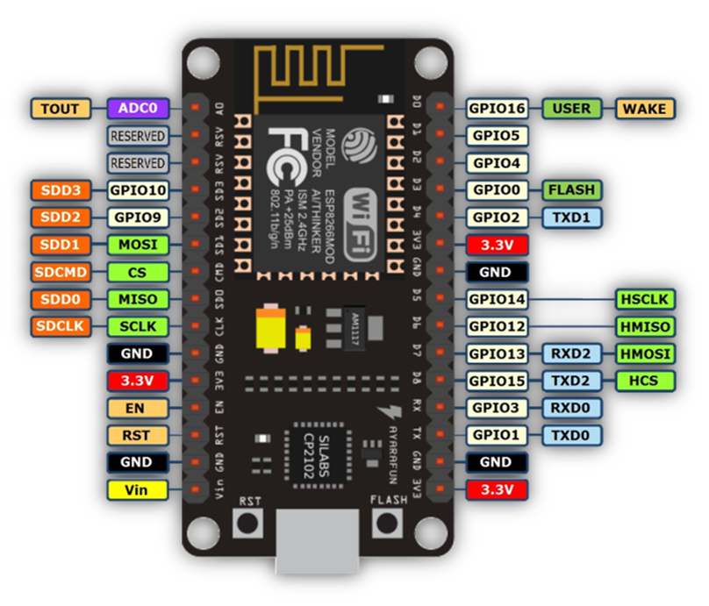

**Figure 4. 3 Pinout Diagram of NodeMCU V0.9 ()**

#### 4.2.1.4 Laptop

To simulate the system and for the result analysis to be presented with all functionality designed minimum requirements for laptop are,

* Windows 7 or above version
* 64-Bit operating system
* Screen resolution : 1024 X 768 pixels
* RAM: 1 Giga Bytes

### 4.2.2 Software requirements

In most of the industries, they are mainly practice to go with simulation design rather than start with an actual product development. By that it is easy to identify any bugs or behavior faults for the system without build it. Design of simulation provides exact behavior of system after implementation in real products. Results are depending on the simulation setup designed. Software plays a key role to design simulation of the system with functionalities.

In the developed system software requirements are also as important as hardware. To improve the result with efficient way, to develop a good system it is necessary to choose appropriate software to design an algorithm of system. Based on the chosen hardware it is discussed in this section to design algorithm for different tasks with better outcome of system.

Some software available for designing the simulation setup are listed in table 4.3.

**Table 4. 3 Software available for simulation design**

|  |  |  |
| --- | --- | --- |
| **Sr. No.** | **Software** | **Language** |
| 1. | LabVIEW | Graphical coding software |
| 2. | MATLAB Simulink® | C, C++, Java, python, and Fortran. |
| 3. | Arduino IDE | C, C++ |
| 4. | Linux | C, C++, Python, java, Pascal, Fortran |

#### 4.2.2.1 Arduino IDE:

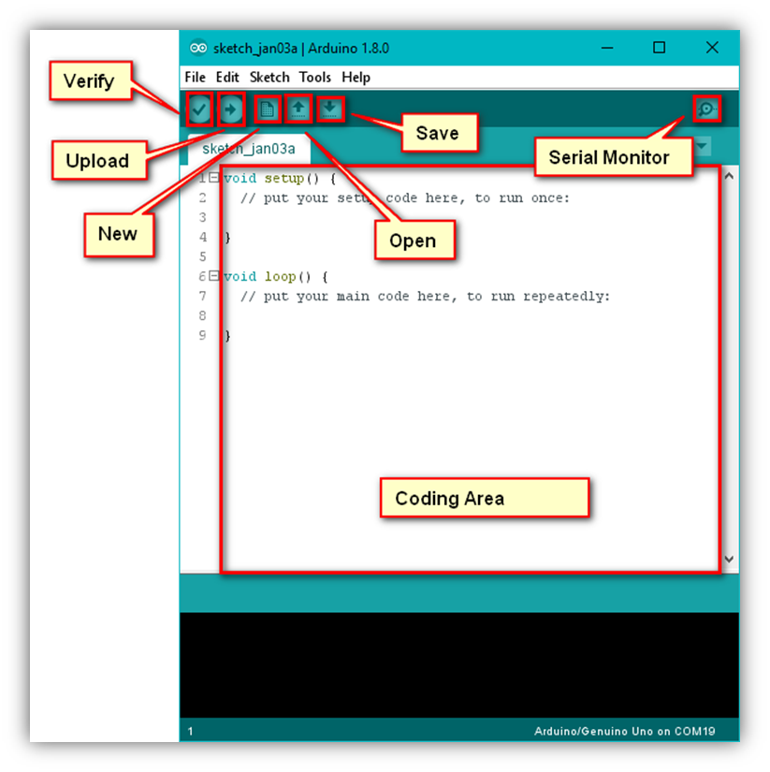Arduino IDE is an open-source electronics platform, it is growing through the contribution of user worldwide based on easy-to-use hardware and software. Arduino IDE script written in in JAVA based on processing programming, AVR-gcc, and other open source platform and it is translated into C language. Programmer can do programming in Arduino programming language and according to wiring, and Arduino software is based on processing programming environment. Arduino (IDE) runs on Mac, windows and Linux operating system. User can easily add AVR C code with Arduino program.

**Figure 4. 4 Arduino IDE software**

#### 4.2.2.2 LabVIEW:

Laboratory Virtual Instrument Engineering WorkBench (LabVIEW) is an interactive graphical programming language that allows for instrument control, data acquisition and pre/post processing of acquired data. In LabVIEW program can be created by graphical symbolization and the principle of dataflow programming, in which functions execute after receiving the necessary data, execution is determine by the structure of a graphical block diagram.

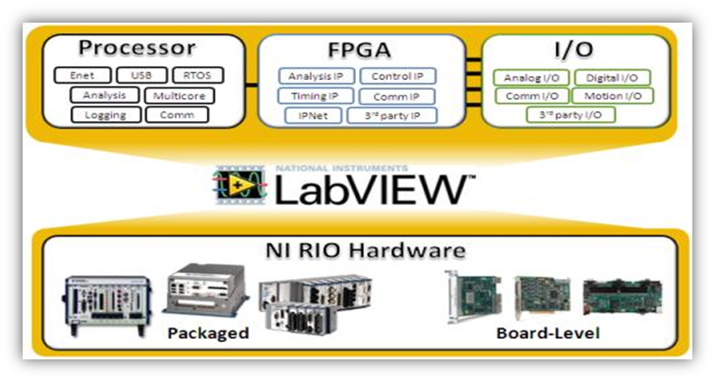A VI has three main parts the front panel, the block (or wiring) diagram, icon/connector. Front panel is one type of window which the user interact with the program. Block diagram window holds the graphical source code of LabVIEW VI and it is actual executable code. Icon characterize the graphical representation in VI block diagram and connector define the input and output of the symbol.

**Figure 4. 5 LabVIEW software**

Programmer can connect different function nodes by drawing wires. When all its data accessible wire spread as variable. This graphical is very beneficial as it enables to assemble programs by dragging and dropping virtual representation of hardware in LabVIEW. LabVIEW provides the additional feature that is include extensive support for interfacing various devices and instruments.

LabVIEW also includes built-in support for NI hardware platforms such as CompactDAQ and CompactRIO, with a large number of device-specific blocks for such hardwares like the *Measurement and Automation eXplorer* (MAX) and *Virtual Instrument Software Architecture* (VISA) toolsets [Mohanraj T, 207].

### 4.2.3 Selected System components and Development costing

From the given functionalities of system and based on all the requirements, chosen hardware and software listed below in table 4.4. As shown, Arduino Uno board have been chosen as hardware and as it is cost effective compared to other boards. Also there is no more requirements for the high configuration board based on system requirements.

**Table 4. 4 Selected system components and total costing for development**

|  |  |  |  |
| --- | --- | --- | --- |
| **Sr. No.** | **System Components** | **Functionality** | **Cost** |
| 1. | Arduino IDE | Establish the Wi-Fi connection | Student edition |
| 2. | LabVIEW | Graphical coding software | Student edition |
| 3. | Raspberry Pi 3 Model B+ | Fetch the data from cloud as well as NodeMCU v0.9 | 375/- |
| 4. | Pulse Sensor | To Measure the pulse | 300/- |
| 5. | NodeMCU V0.9 | Provide Wi-Fi connectivity | 575/- |
| 7. | Connecting wires | To connect all sensors with Arduino UNO | 50/- |
| TOTAL COST FOR DEVELOPMENT OF SYSTEM | | | 1750/- |

For the simulation set up Labview is more effective for graphical representation and it is interfacing with raspberry pi through LINX package. For system design a model LabVIEW software is used. In body monitoring and reporting system using time series analysis it can be design for monitoring a patient`s heart rate and analyze the measured data using ADVANCE Toolkit of Time Series Analysis. NodeMCU and sensor are interface with the Arduino IDE for serial communication.

## 4.3 Design Specification

* When system is initialize, sensor fetch the pulse data from the user body. After Pulse sensor code convert pulse sensor value in heart rate according to beats per minute.
* Calculated heart rate value and transmitted to Raspberry Pi through NodeMCU v0.9 also send to the cloud data base.
* Raspberry Pi fetch sensor data forward to the LabVIEW for further simulation process.
* If the Wi-Fi module and Raspberry pi is disconnected from Wi-Fi connectivity. NodeMCU fetch data directly transmitted to cloud database. After that Raspberry Pi fetch data from the cloud i.e. things speak channel and forward to LabVIEW for further analysis process.
* Raspberry Pi interfacing using LINX with IP address for communication between Pi board and LabVIEW.
* Pulse sensor data compare with the threshold data set value. If the real time data is less than or greater than the Threshold value, developed system identify the abnormality of the diseases.
* If the pulse sensor data is equal or in between range of the threshold set value it return fetch the sensor data continuously.
* Based on the real time data value comparison, developed system predict the future condition using ARMA modelling and prediction time series analysis.
* Based on these predicted value and obtained predicted series results, system will calculate the criticality rate i.e. how much time is critical for the user.
* Based on the criticality rate and predicted series, developed system notify to the person, their relatives and concern personnel consultant in medical domain.
* Based on these predicted value and obtained results it returns the monitoring and reporting system in the designed GUI in LabVIEW.

## 4.4 System Design

System design gives exact idea for the implementation and development stages. It includes, Block diagram, data flow chart, algorithms etc.

### 4.4.1 Block diagram of system

The system can be identified with the flow and directions of its connections with other peripherals and sub components in the system. For the developed system, figure 4.6 shows the high level block diagram of the body monitoring & reporting system with inputs provided to the controller unit for desired results at end of the system.

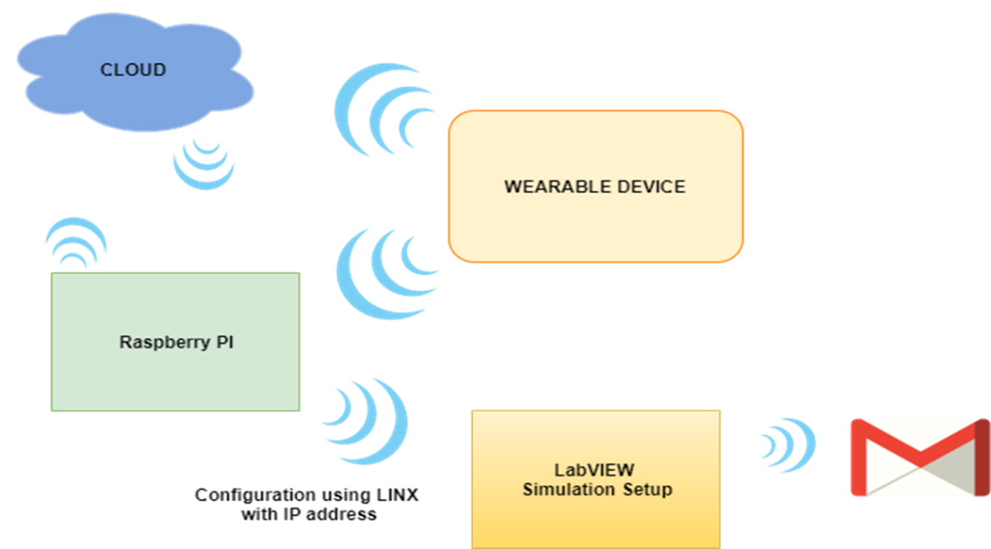Additionally for more detailed outputs the blocks in high level diagram will get divided in to different bio medical sensor modules and also includes ECU with processor and cloud database.

**Figure 4. 6 High level Block diagram for system**

Figure 4.7 depicts the low level diagram of body monitoring and reporting system with connections and direction of communications.

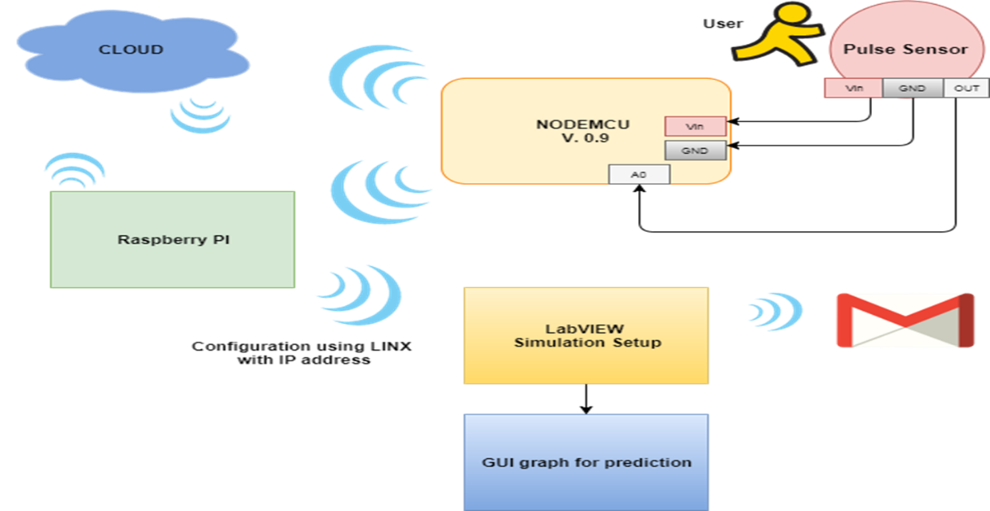The system will measure the data of patient’s body with different biomedical sensors attached as an input stages. Furthermore the data will get fetched and sent over the cloud to create a history of data and for analysis next stage of diagram includes, ECU as a Raspberry Pi board with designed algorithm for analysis. It monitors the abnormality in the patient’s body and if criticality identified it will notify the person.

**Figure 4. 7 low level Block diagram for system**

### 4.4.2 Schematic Diagram

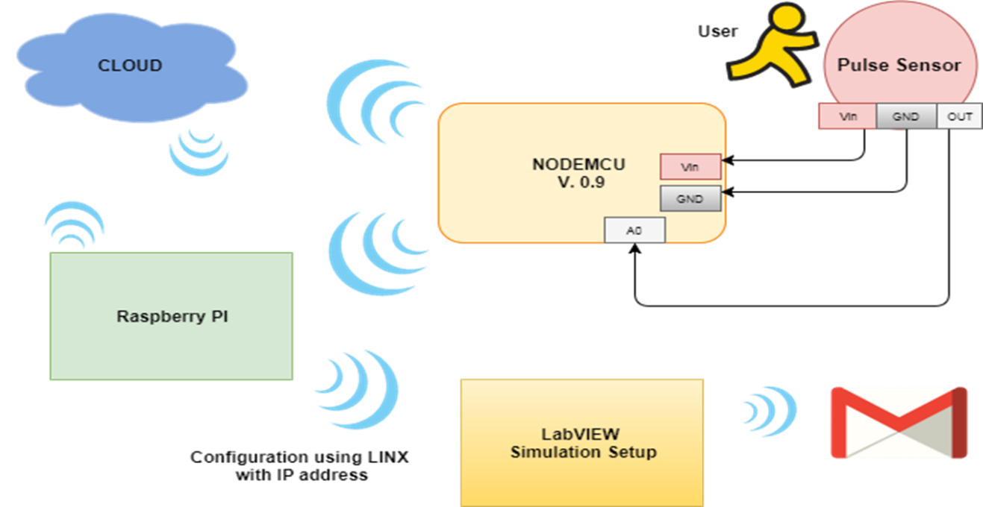Schematic diagram provides visual presentation of the system that describe the interconnection between each sub system and it has enough detail to connect an electronic circuit.

**Figure 4. 8 schematic Diagram of the System**

In Figure 4.8 schematic diagram of the system, Pulse sensor fetch the pulse data from the user`s body. Pulse sensor connected with the NodeMCU V0.9 Module for provide Wi-Fi connectivity accessible between sensor and cloud storage as well as Raspberry Pi. Input voltage and GND pin are connected with NodeMCU pin of input and GND. Output pin of sensor connected with A0 pin of Wi-Fi module. Raspberry Pi Board is configuring using LINX with IP address for communication between Raspberry Pi and LabVIEW. LabVIEW Send email through the SMTP protocol.

### 4.4.3 Flow chart of system

Flow chart of any system will show the actual flow of data as per the system’s functionalities. Figure 4.9 shows the flow chart of prognosis based body monitoring and reporting system with working process. It depicts the actual process of working of system with different stages as shown 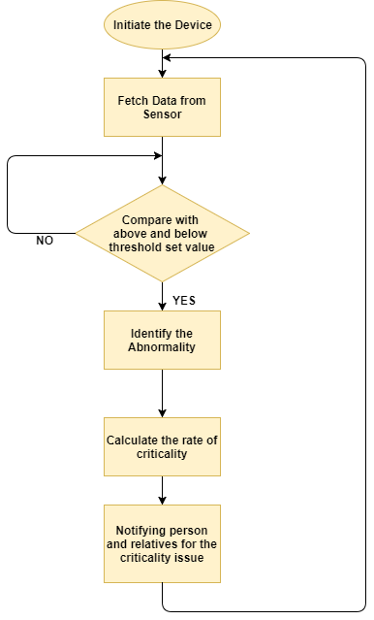below.

**Figure 4. 9 Flow chart of the System**

when system initialise the device it will fetch data from the sensor continuously. After collecting sensor value it will compare fetch data with the normal or threshold set value if the data is greter than or less than the threshold set value it will identify abnormality of the diseases. After that it will calculate data rate of criticality based on the reading collected in real time and predict future condition of the patient. And predicted value get displayed over GUI designed for the simulation set up of the system. All history of the patient data will get stored over a cloud using GUI designed in LabVIEW simulation set up. At the end side system will notify the person, relatives and medical center for the criticality issue. Loop continuously monitoring and fetching the real time data of the patient.

## 4.5 Implementation of System

The implementation is divided into two parts hardware and software implementation. The software implementation is done using Arduino IDE, python and LabVIEW. And hardware implementation includes the sensor, actuators and embedded board.

### 4.5.1 Hardware Setup:

**Figure 4. 10 Hardware setup of System developed**

The figure 4.10 shows the hardware setup for proposed system, based on proposed design. The arrangement of the hardware based on the system requirement. NodeMCU v0.9 Wi-Fi module is used for data fetch from sensor and transmit to the cloud storage as well as send to the Raspberry Pi. Raspberry pi is used for sensor data fetch from cloud and transfer to the LabVIEW for further analysis of the real time data.

### 4.5.2 Software Setup:

Software set up is a part of the developing process to getthe software part of the system. There are three different software used for developing the system. Arduino IDE is used to dumb the code in NodeMCU V0.9 Wi-Fi module. LabVIEW is used to analyzing and predicting the patient`s future condition based on the real time data. Python code is used for communication between Raspberry pi and LabVIEW.

#### 4.5.2.1 Simulation set up of NodeMCU and Arduino IDE:

**Step 1: Downloading and installing the Arduino IDE**

**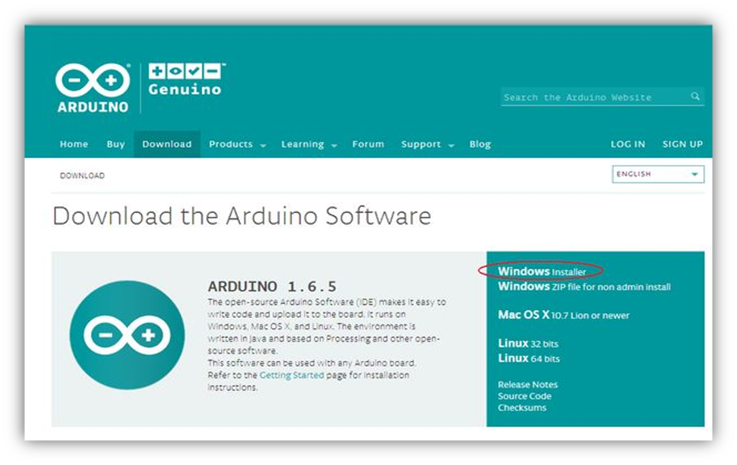****Figure 4. 11 Installing IDE**

**Step 2: find the preference dialog.**

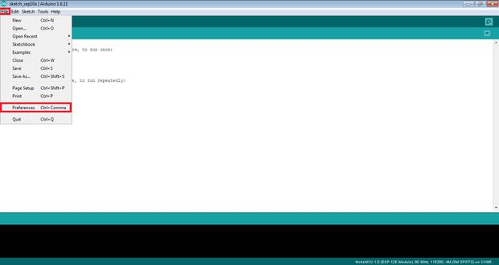First open the Arduino IDE and go to file menu select the preference click on it. After that it will open the preference dialog box it is shown in below figure 4.12.

**Figure 4. 12 Preference Dialog box**

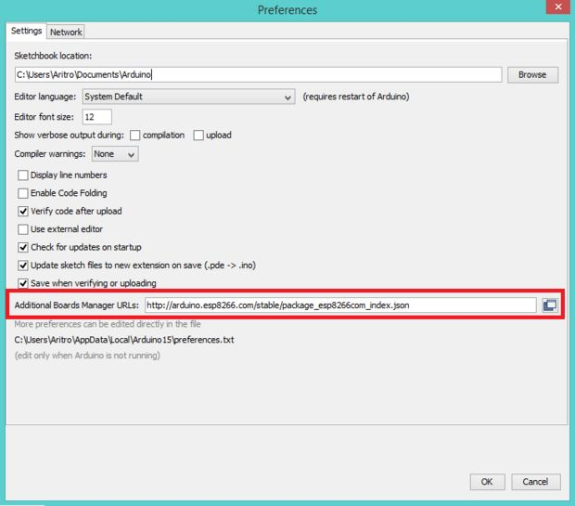In this figure 4.13 preference dialog box we have to need give URL of the ESP8266 data package path.

**Figure 4. 13 Preference Dialog box for URL Path**

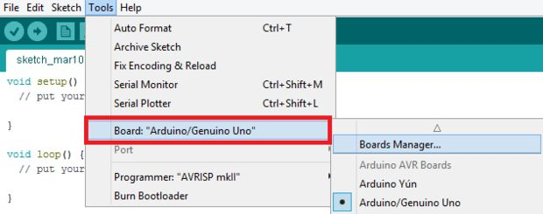**Step 3: where to find Board manager dialog**

**Figure 4. 14 Board manager Dialog**

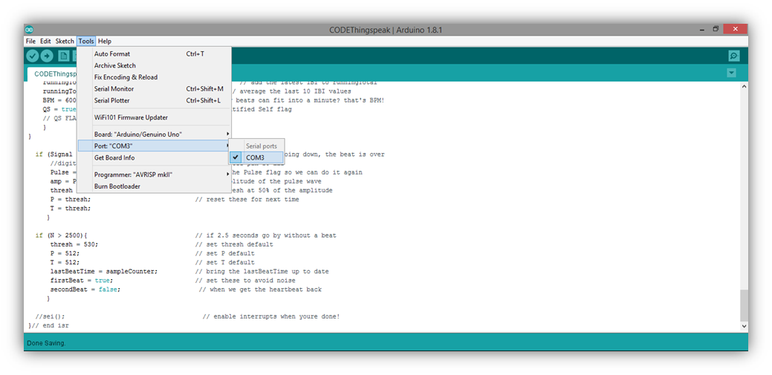**Step 4. Determining the COM port**

**Figure 4. 15 Determining COM port**

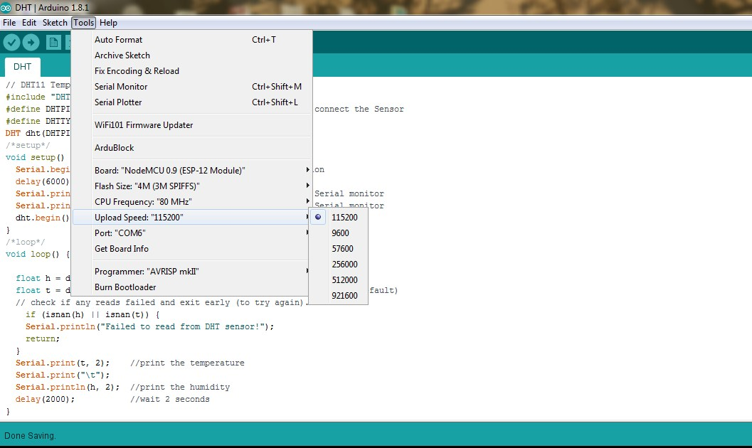**Step 5** **. Configuring the COM port Speed**

**Figure 4. 16 configuring COM port Speed**

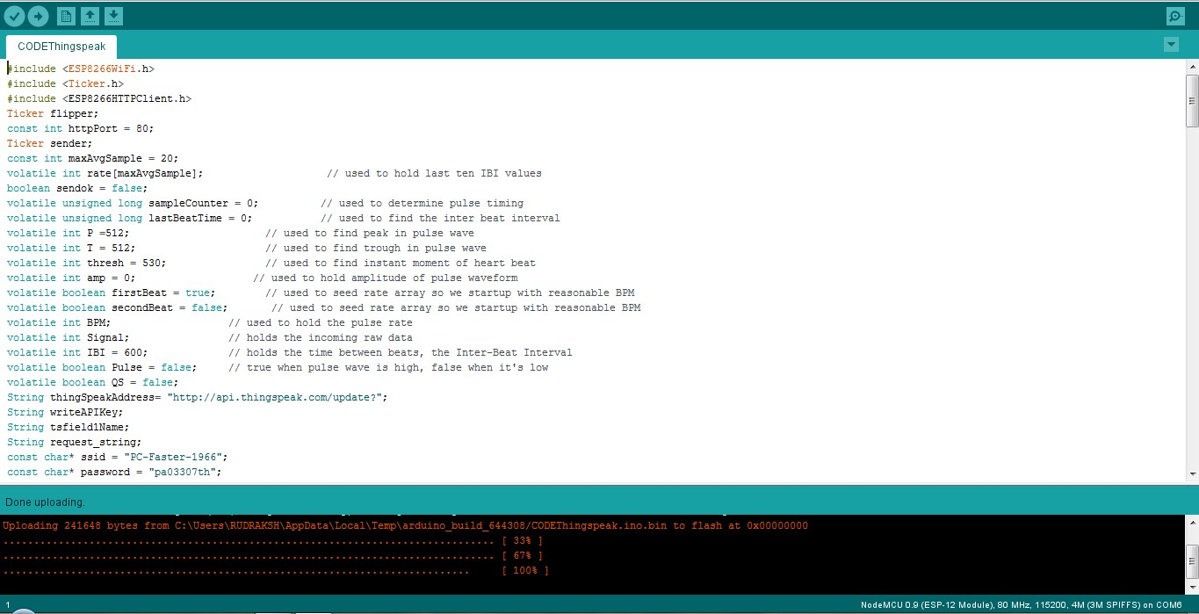**Step 7. Test Drive the Set up.**

**Figure 4. 17 Upload the code**

#### 4.5.2.2 Simulation Set-up in LabVIEW:

LabVIEW simulation Set-up designed is graphically code representation of the developed system design. For create a project for developed system some basics step required to follow which is enlisted below with screenshots,

**Step 1:** Start LabVIEW software.

**Step 2**: Go to create project option and click on it.

**Step 3**: in figure 4.18 select the blank project and click on finish button. It will give the prompt with project tree which is includes sub Vis configuration window.

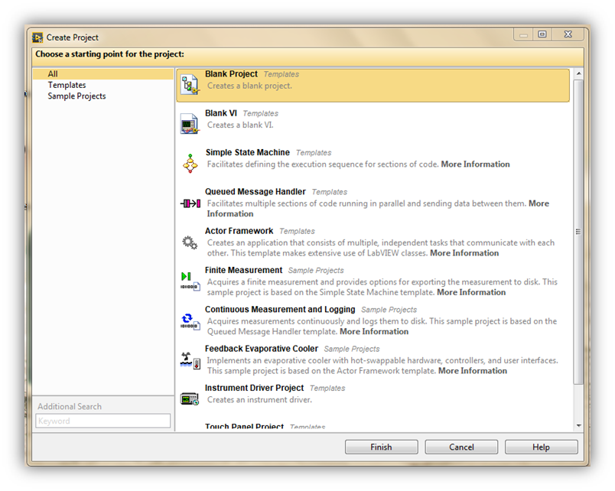**Step 4**: for create a new VI go to My Computer option and click on it in given window. Shown in Figure 4.19

**Figure 4. 18 Create Project**

**Step 5:** After creating a new project VI it will give blank block diagram window for develop system design and front panel windows for develop GUI for designed system shown in figure 4.20, 4.21

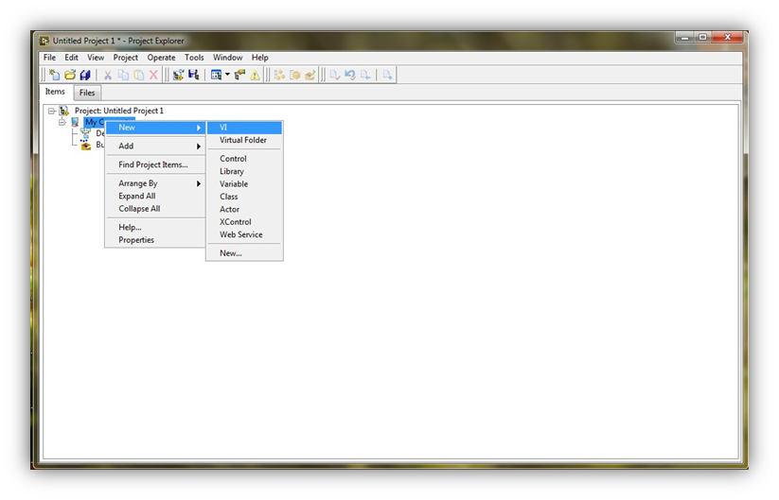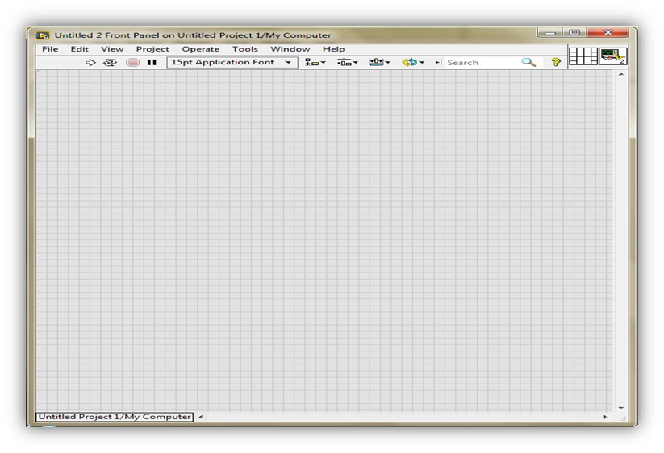

**Figure 4. 19 Create a new VI**

**Figure 4. 20 Front panel window for Create project**



**Figure 4. 21 Block Diagram Window for Create new Project**

### 4.5.3 System Implementation and Design in LabVIEW

#### 4.5.3.1 Implementation between NodeMCU and Arduino IDE

In Arduino IDE software, the scholar is going to write the code for read the pulse sensor data and transmit to the cloud. Code for pulse sensor.

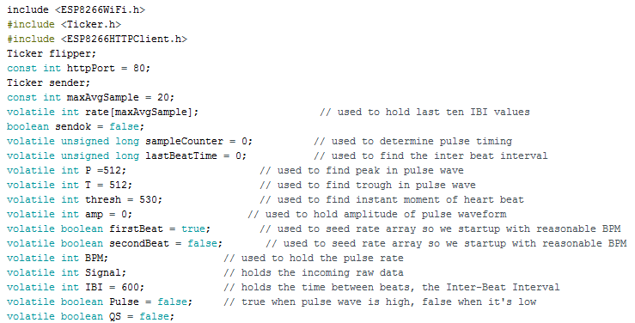

**Figure 4. 22 Initialization of library**

Here, above figure 4.22 has code for initialization of library for ESP8266 Wi-Fi module, ESP8266HTTPCLIENT service and Ticker.h library used to set up a recurring interrupt to repeatedly call a function at a specific rate. After initialization of the libraries we have to initialize variables for future purpose.

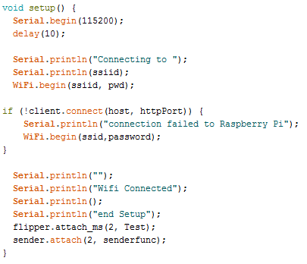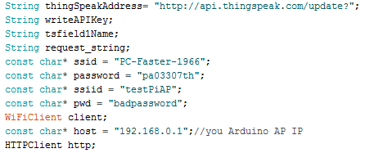In above figure 4.23 and 4.24, Set the thing speak channel address and SSID and password of Wi-Fi connection. Then it will send the request to the server for establish connection to thing speak URL and set the KEY of the thing speak channel for read and write the data on thing speak channel. And print Wi-Fi connected on serial monitor of Arduino IDE.

**Figure 4. 23 Print the Wi-Fi is connected**

**Figure 4. 24 Set password and SSID for Wi-Fi connection**

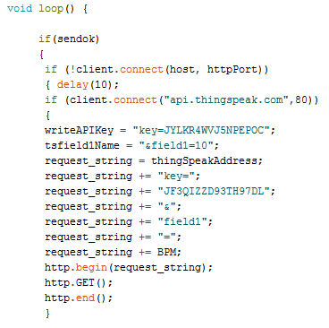

**Figure 4. 25 Set Thing speak channel KEY**

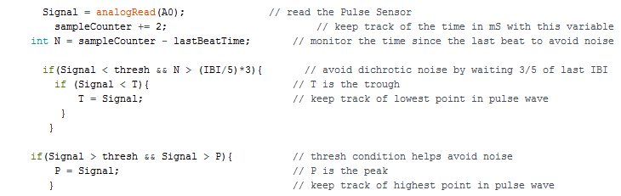in above snippet 4.25, make loop for data fetch from sensor to cloud and set the write and read key given by thing speak channel and send the HTTP client request.

**Figure 4. 26 Pulse Sensor Code**

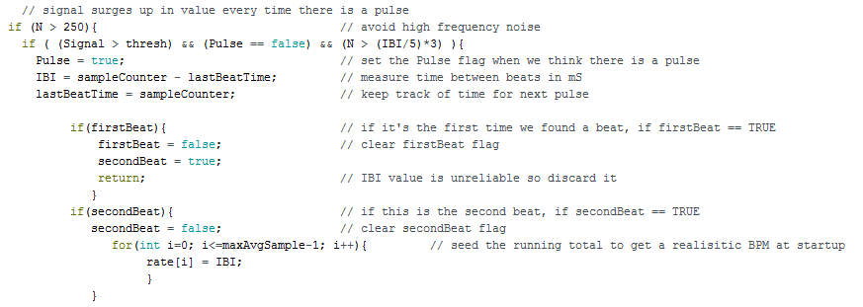In this figure 4.26, signal read the analog value of the pulse sensor through A0 pin after set the counter value by increasing one. LastBeatTime variable helpful for monitor the time and removing the noise from sensor data. After that signal compare with the threshold value and it helps to avoid dichrotic noise.

**Figure 4. 27 Fetch Pulse Value**

now in figure 4.27, it is looking for the heart beat rate and signal flows up in every value according to the patient`s pulse data. It will continuously monitoring and fetch the pulse rate increasingly one by one till condition is TRUE.

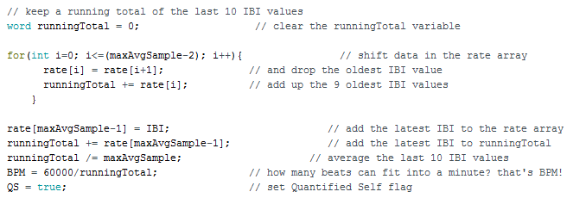

**Figure 4. 28 SET Counter value**

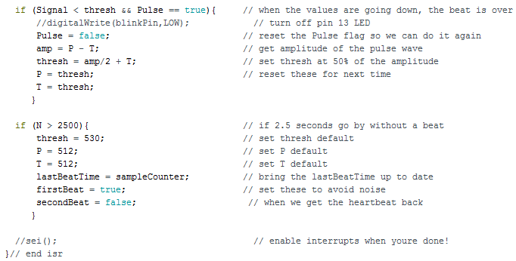Every IBI i.e. beat per minute value stored in rate array up to 9 oldest IBI value. After it will add all oldest IBI value calculate average of the last 10 IBI value and check out how many beats can fit in to a minute.

**Figure 4. 29 calculate Heart rate**

in end of the figure 4.29, when the value are going down then the set threshold and peak value, the beat is over after that it will reset the Quantifies self-flag and get the amplitude of the pulse wave and set threshold value 50 % of the amplitude. After it will reset for next time.

#### 4.5.3.2 Design in Labview Using TSA ARMA Modeling and Prediction:

**Figure 4. 30 ARMA Modelling and Prediction in LabVIEW**

Table 4.5 shows the working and functionality for each blocks used in the ARMA model and prediction block diagram for Body monitoring and reporting system. Blocks used explained with its basic usage for the designed system as in block diagram shown in figure 4.30.

**Table 4. 5 Functional blocks and its working**

|  |  |  |
| --- | --- | --- |
| **Functional Blocks** | **Symbols** | **Working** |
| **Read from the text file function** |  | In this block, prompt function open that appears above attach list of files and file dialog box used to display select file. If the relative file path does not exit, this function returns an error. Count function is read to maximum number of character. Refnum out is the Refnum of the file. Text read the data from file. Cancelled function useful for check the condition, if the file path is correct it will read the file data otherwise return an error and error out contains error information. |
| **String to byte array function** |  | This function is used to convert the character to ASCII value. |
| **Sawtooth** | C:\Users\Pari Patel\Downloads\s.png | Sawtooth Function generate the sawtooth value and plot the graph according to given input data. |
| **While Loop** |  | In while loop, sub-diagram contains code that the while loop execute once per iteration and iteration terminal provides the current loop iteration. Count conditional terminal executes the input value to determine continue executing the while loop |
| **Wait function** |  | Wait function specifies how many milliseconds to wait for execute the function twice |
| **IIR Filter** |  | In this block, init/cont provides control of the internal state. X is the input array of sample to filter. Reverse and forward coefficient set according to data for filter design. Filter X shows the array of filtered sample as output |
| **TSA ARMA modelling VI** |  | Xt specifies the univariate time series. Method estimating the ARMA model. High order AR method used to computes the Autoregressive (AR) and Moving average (MA) coefficient with AR model. In this method AR and MA coefficient values are default set 4 and 3 respectively, Otherwise it must be equal to or greater than 0. Noise returns the estimated white noise. |
| **Build Array function** |  | This function wired the input element or 1-D array to appended array. |
| **TSA prediction** |  | In this block AR and MA coefficient obtained using ARMA modeling. Error in identify the error condition if the error occurred before node runs. Predicted series returns the predicted univariate time series and standard deviation provides the deviation of each predicted value. |
| **Waveform graph** | C:\Users\Pari Patel\Downloads\wf.png | It will generate the waveform to output of predicted value. |

#### 4.5.3.3 Graphical User Interface in LabVIEW:

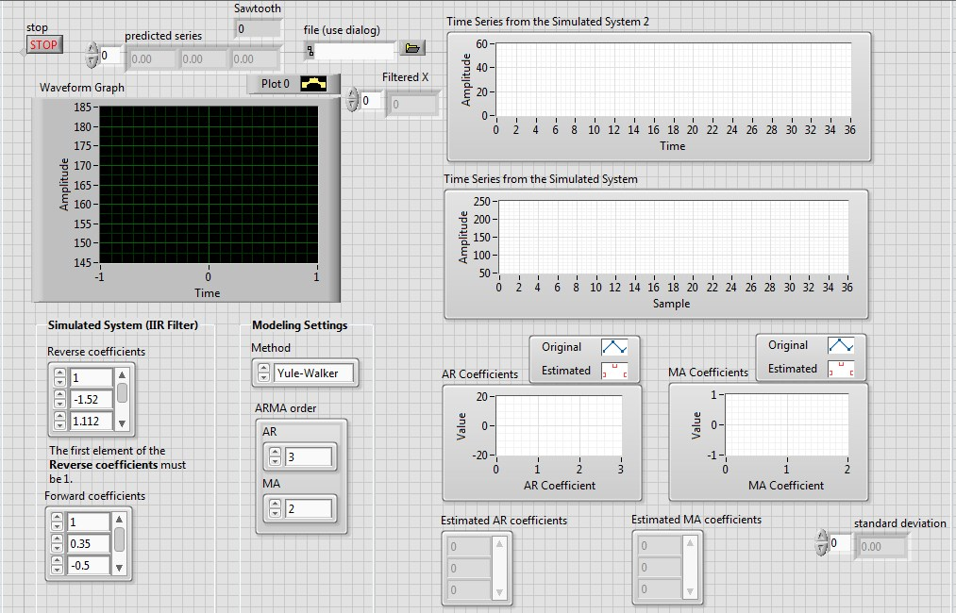In figure 4.31, Predicted Series shows the predicted value sawtooth box shows showtooth value of the raw data and filter. Reverse coefficient and forward coefficient set by Ni Instrument. High order AR method is used for ARMA modeling and Prediction. ARMA order set according to our requirement. In AR coefficient graph Blue line indicate the original value and red dots indicate estimated value. Estimated AR and MA coefficient used for predict the future value. Standard deviation give the error between original data and predicted data.

**Figure 4. 31 Graphical User Interface for ARMA Modeling and Prediction**

#### 4.5.3.4 Design in LabVIEW for SMTP protocol:

**Figure 4. 32 SMTP Protocol Design**

**Figure 4. 33 SMTP Protocol design**

In figure 4.33 first, we have to set all the information about sender and recipient`s address and name and it will forward to the mail message and enter Carbon copy recipient address after that check the condition if user entered a CC address, process is done and mail forward to attach body message or any attachment file.

In figure 4.32 after forward for attach body message or any attachment file it will check condition. If condition is true i.e. user selected an attachment and forward to smtpclient for sending the message. When SSL button is enable it will give accessibility to network connectivity for sending the e-mail.

#### 4.5.3.5 GUI design in LabVIEW for SMTP Protocol:

**Figure 4. 34 GUI Protocol for SMTP Protocol**

#### 4.5.3.6 Communication between Raspberry Pi and Cloud:

**Figure 4. 35 Python code for fetch data from cloud**

Figure 4.35 shows python code for the data fetch from thing speak channel to raspberry pi. For communication between raspberry pi and cloud we have to initialize the library i.e. import urllib2 and json. Then READ_API_KEY and CHANNEL_ID shows the API_KEY and ID of the thing speak channel created. Urllib2.urlopen give permission to access to read data from given thing speak channel authenticated with thing speak channel key and id defined. Connection established with conn.read() function and json.load(response) give the response to generated channel code. Data read from the channel will get printed on the console with given parameters and that same data will get stored in the text file created after that. For the continuous working the same system the code is executed with infinite while loop condition. Every time after updating the value in the text file the connection will get closed.

## 4.6 System Integration:

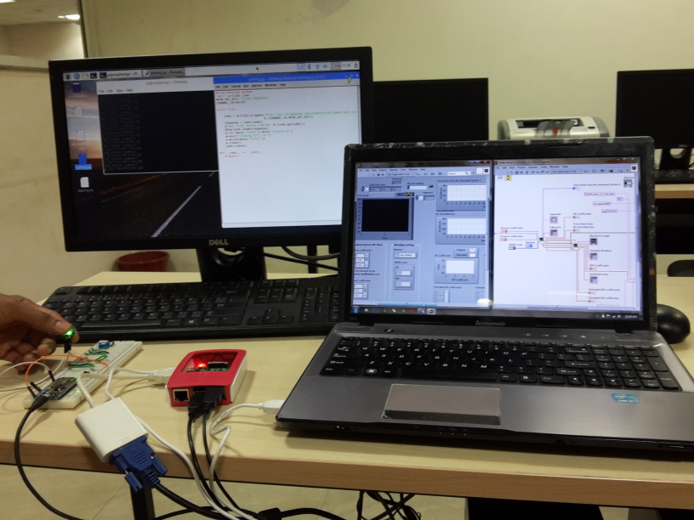After implementation done on software to design the simulation of system to calculate criticality rate based on the predicted series value, it is required to integrate all the parts i.e. hardware and software for testing the system and to obtain the results. As shown in figure 4.36, the system integrated with LabVIEW using LINX and the analysis results obtained is discussed in next chapter with details.

**Figure 4. 36 System setup after Integration**

# 5. Results and Discussions

In this chapter of dissertation work after the developed system tested for the working functionality. The body monitoring and reporting system developed and implemented is tested based on unit testing, integration testing and system level testing.

The testing is done with the developed simulation setup in LabVIEW and Arduino IDE. LabVIEW and Arduino IDE code tested and shown results for each type of test cases carried for that system.

All test cases developed discussed in this chapter and based on the results for each test cases the developed system tested at integration and system level.

## 5.1 Unit Testing

Unit testing for any system is done with each component and functionality of the individual component for system. It comprises both types of testing software simulation side and hardware side.

In this testing it involves to test the functionalities of pulse sensor in Arduino IDE for the developed system.

* To test functionality of pulse sensor as analog reading in Arduino IDE.
* To test functionality of NodeMCU v0.9 as Wi-Fi module is connected in Arduino IDE.
* To test functionality of Raspberry pi after installing the operating system (OS).
* To test functionality of SMTP GUI as a send e-mail.

For the develop test cases, table 5.1 shows all test cases with the expected result.

**Table 5. 1 Unit testing for hardware**

|  |  |  |  |  |  |  |
| --- | --- | --- | --- | --- | --- | --- |
| **Unit Test Case ID (UTC)** | **Test Case** | **Input Data** | **Test Process** | **Expected Result** | **Actual Result** | **Figure**  **No.** |
| UTC_01 | Pulse sensor value given as input to Arduino IDE using NodeMCU | Pulse sensor value | Connection establish by the NodeMCU and it is connected to Arduino IDE | Should show the analog value according to real time data | Giving immediate response for the change in analog values | 5.1 |
| UTC_02 | NodeMCU working | NodeMCU connected to PC with | whether LED is blink or not | LED should blink | LED blink | 5.2 |
| UTC_03 | Raspberry Pi working | Raspberry Pi connected to PC by Serial cable. | After installing OS it will check whether it work or not | Board should work properly | Fetch the data from cloud and transmit to the LabVIEW | 5.3 |
| UTC_04 | SMTP Protocol testing | Recipient`s Address | Send the message to recipient | E-mail should be send | E-mail sent successfully | 5.4 |

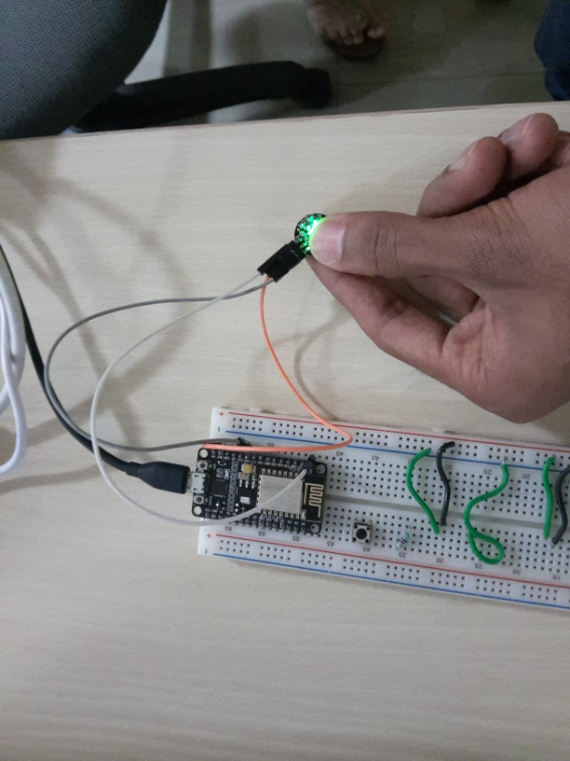The unit testing is done to verify the functionality of the system develop with the simulation set up built for taking input value from the sensor of the system. As shown in figure 5.1 to 5.4 are expected for the unit test cases.

**Figure 5. 1 pulse sensor Testing**

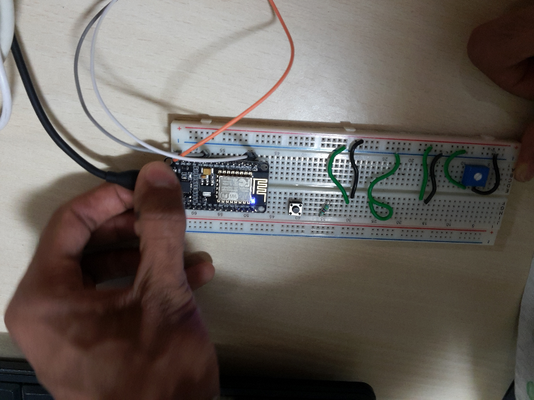

**Figure 5. 2 NodeMCU V0.9 Testing**

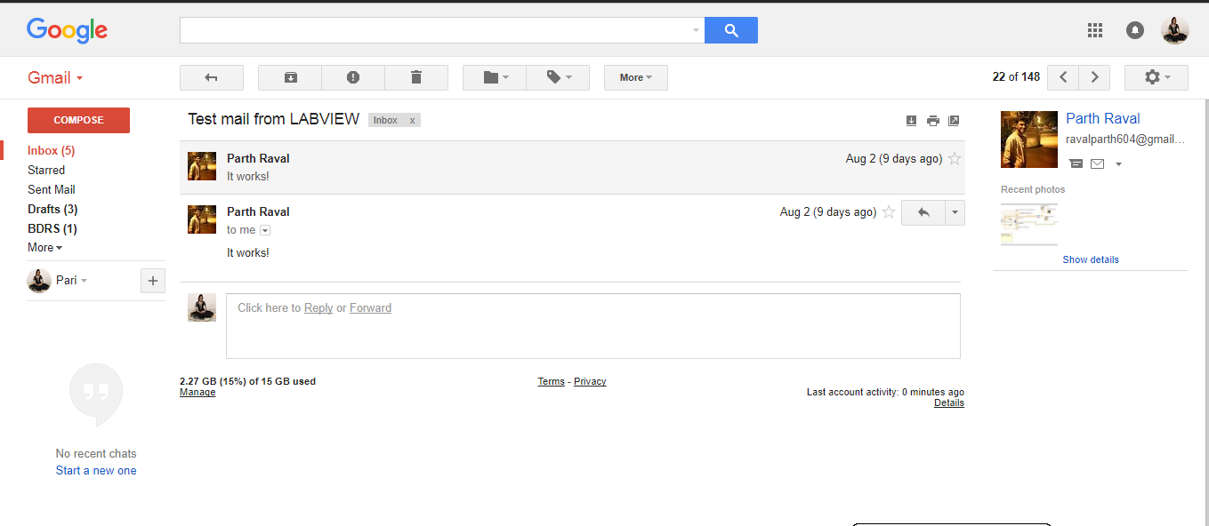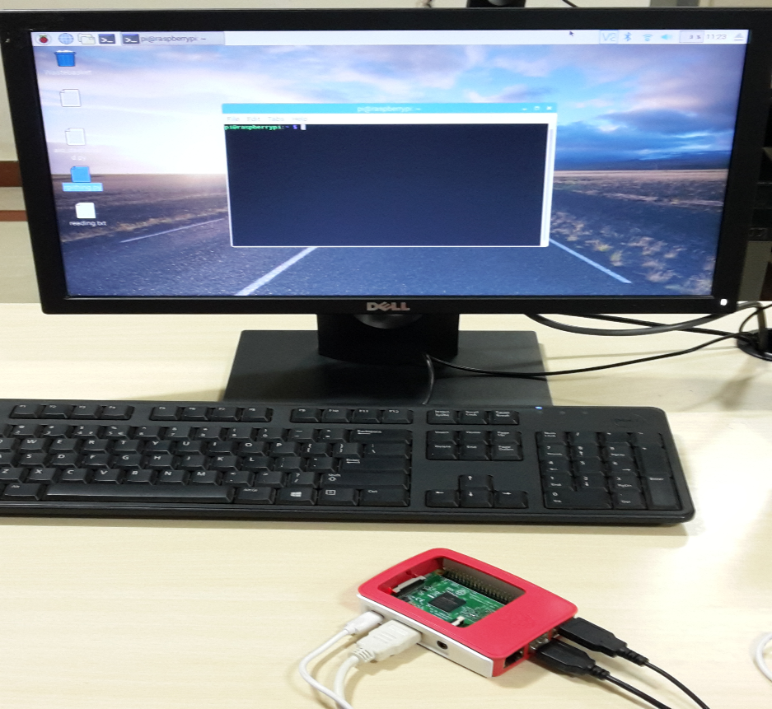

**Figure 5. 4 SMTP Protocol Testing**

**Figure 5. 3 Raspberry Pi Testing**

## 5.2 Integration Testing

For the integration testing sub system will combined and tested together. For integration testing consider following test cases,

* To test for sensor data send to Raspberry pi.
* To test for sensor data fetch from cloud to Raspberry Pi.
* To test for sensor data send from NodeMCU V0.9 to cloud.
* To test for sensor data transmit from Raspberry pi to cloud.

Table 5.2 shows all test cases carried out for integration testing of the system. It includes the test procedure and results as obtained for each of them.

**Table 5. 2 Integration Testing**

|  |  |  |  |  |  |
| --- | --- | --- | --- | --- | --- |
| **Integration Test Case ID (ITC)** | **Test Case** | **Input Data** | **Test Process** | **Expected Result** | **Actual Result** |
| ITC_01 | To test the sensor data to Raspberry Pi | Input comes as an analog value from Pulse sensor | NodeMCU sense the data from pulse sensor and send it to Raspberry Pi Access point | Should able to send sensor data to Raspberry Pi | Pulse sensor data successfully sent to Raspberry Pi |
| ITC_02 | To test for fetch sensor data from cloud to Raspberry Pi | Wi-Fi connection | Whether it will check Wi-Fi module is connected or not | Wi-Fi connection should be establish | Wi-Fi connection successfully establish |
| ITC_03 | To test for send sensor data from NodeMCU V0.9 to Cloud | 5V Battery | Establish the connection and send sensor data to cloud through NodeMCU | Pulse sensor data should be send to cloud | Pulse Sensor data successfully sent to cloud |
| ITC_04 | To test for transmit the sensor data from Raspberry Pi to cloud | Wi-Fi connection | Whether it will check Wi-Fi module is connected or not | Wi-Fi connection should be establish | Wi-Fi connection successfully establish |

## 5.3 System level Testing

For the system level testing some test cases can be given as,

* To test functionality for NodeMCU to Raspberry Pi.
* To test for Raspberry Pi fetch data from cloud.
* To test Prediction in LabVIEW.

**Table 5. 3 System level testing**

|  |  |  |  |  |  |
| --- | --- | --- | --- | --- | --- |
| **System level Test Case ID (ITC)** | **Test Case** | **Input Data** | **Test Process** | **Expected Result** | **Actual Result** |
| STC_01 | To test NodeMCU to Raspberry Pi and Cloud | Input analog signal came from the Pulse sensor | NodeMCU will fetch the data from Sensor and send it to the Raspberry Pi Access point and cloud database. | Data should be send to Raspberry Pi as well as Cloud | Data successfully sent to Raspberry pi and cloud |
| STC_02 | To test for Raspberry Pi fetch data from cloud | Wi-Fi connectivity | If Wi-Fi connection is establish, Raspberry Pi input analog data fetch from the cloud for further analysis | Should Analog input data fetch from the cloud database | Analog input data successfully read from the cloud storage. |
| STC_03 | To test prediction in LabVIEW | From Raspberry Pi i.e. text file | Text file give to LabVIEW and it will predict the estimated value using ARMA modelling and Prediction | Should give predicted data series according to Pulse sensor data | System given predicted data series according input data file |

## 5.4 Result Analysis

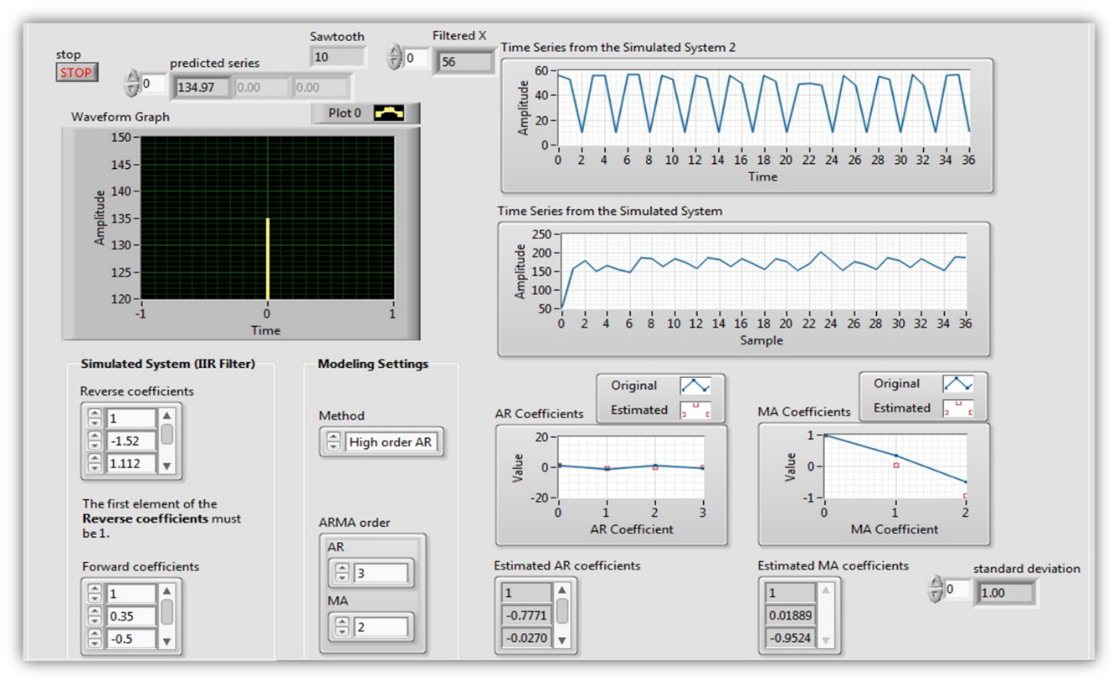Based on the addressed problem identification and the requirement analysis done on the research gaps. The system proposed with some additional solutions. After implementing the system on hardware and simulation design done on software chosen, Results for the developed system are shown in this section of the thesis. Results obtained are for some analog signal values collected from Pulse. These pulse sensor data sent to cloud as well as Raspberry Pi through NodeMCU V0.9 module. Raspberry Pi will send the data to LabVIEW for further analysis. After that LabVIEW predict the patient`s criticality state and alert to user as well as health care taker. Based on implemented design and logic applied for the system, results shows the considerable improvement for Body monitoring and Reporting System.

**Figure 5. 5 Results of Predicted Series**

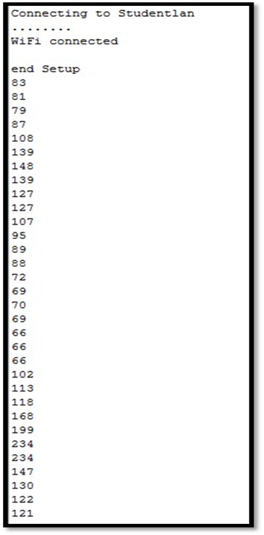above figure 5.6 shows the real time data fetch from the user`s body through pulse sensor. Fetch data shows in Arduino IDE of serial monitor. It also shows the Wi-Fi connection is establish and print all real time data of users.

**Figure 5. 6 Pulse sensor Reading**

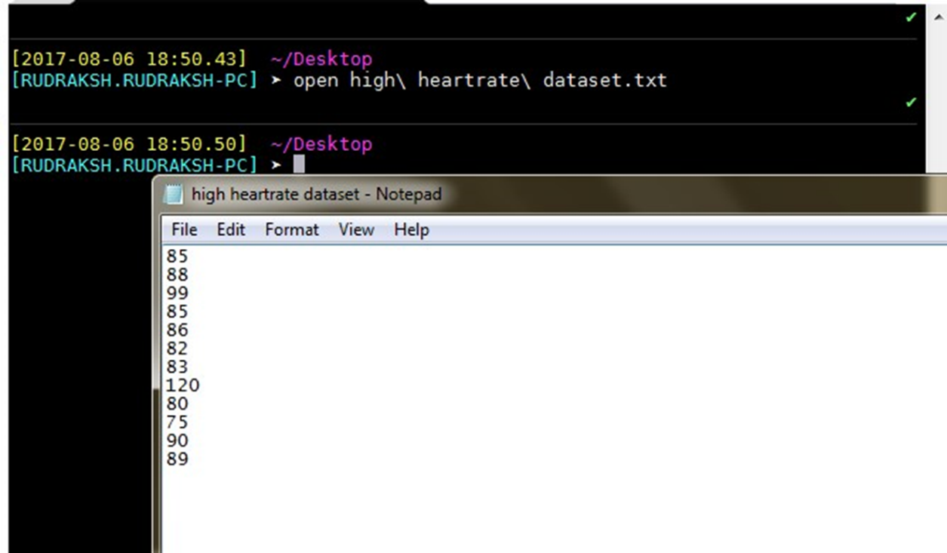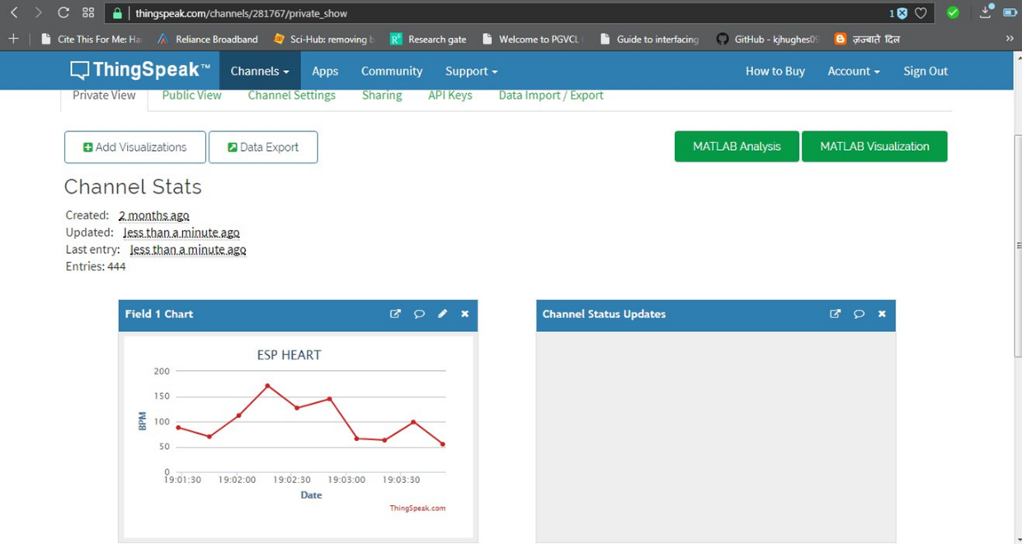In figure 5.8 shows fetch sensor data forward to could i.e. thing speak channel and shows the real time data graph and value. In figure 5.7 shows Raspberry Pi data fetch from cloud and file convert into text file format.

**Figure 5. 7 Raspberry Pi convert Data file into Text file**

**Figure 5. 8 Sensor Data send to cloud**

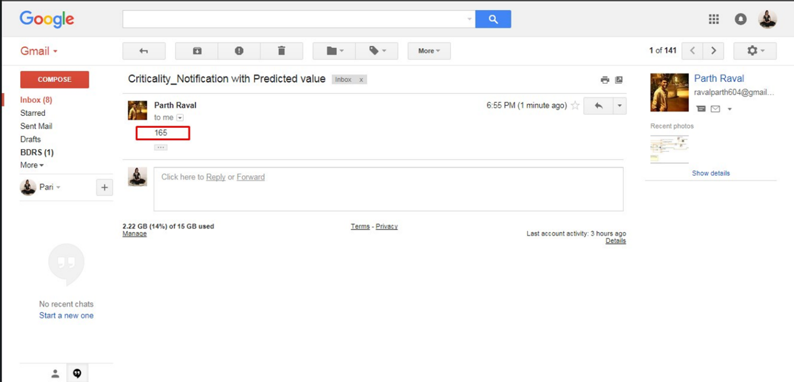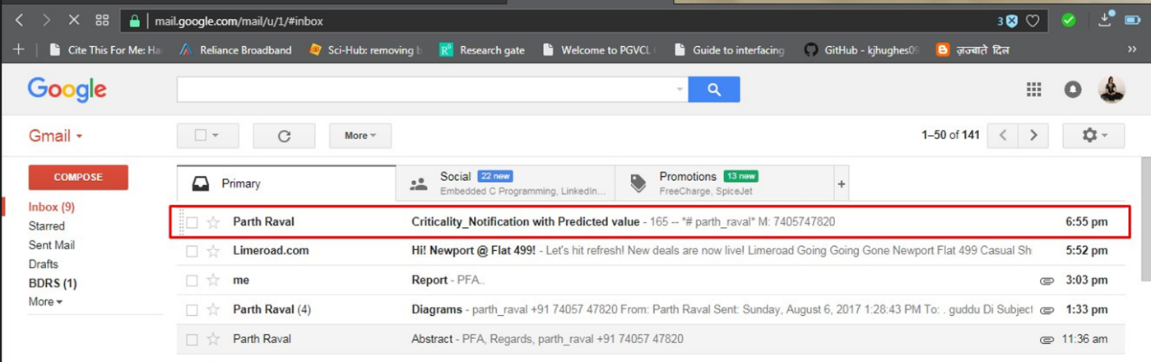in figure 5.10 shows get the notification E-mail through SMTP protocol designed in LabVIEW, if the abnormality occurred and user`s health in critical situation. Figure 5.9 shows get E-mail with predicted value and text message from criticality of disease.

**Figure 5. 10 GET Criticality Notification through E-mail**

**Figure 5. 9 Get E-mail with Predicted Value and message for Criticality of disease**

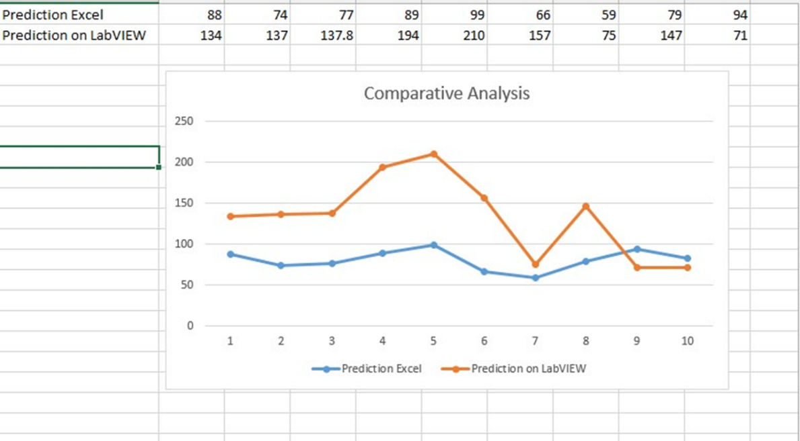Above figure 5.11 shows the standard error deviation between theoretical and practical predicted value. From this analysis graph we can identify the system accuracy.

**Figure 5. 11 Prediction Accuracy Difference between EXCEL and LabVIEW**

# 6. Conclusions and Future Directions

## 6.1 Summary of Work

As Human health is getting affected by various factors from an environment such like, simple health issues e.g. Fever, Flu, Viral infection etc., it is required to develop a system to secure the patient’s health before the critical state to be reached. Developed prognosis based Body monitoring and reporting system using ARMA modeling time series analysis can be used to measure current situation of patient’s health and can also be used to identify the criticality rate for the person before it going to meet abnormal condition.

It can be conclude from the obtained result that, there is significant change in heart rate it will identify the abnormality of disease. Based on prognosis condition system will predict the future condition of the user and notify the user or medical experts. It calculates the criticality rate which plays major role in the system and obtains results for the disease which will helpful to control it before the critical situation to be occurred.

System features can be expand by adding more vital sign parameter other than heart rate. The efficiency of the system can be improved by designing a new methods and algorithms.

## 6.2 Conclusion

* Pulse Sensor readings transmitted to Raspberry pi and cloud through NodeMCU V0.9 Module.
* Raspberry Pi fetch the data and transmit to designed system
* Critical rate calculated from the predicted value and identify the abnormality of the disease.
* The predicted value sent through SMTP protocol from LabVIEW to registered e-mail account.

## 6.3 Future Work

It is important aspect to consider the future expansion of any developed work and to concentrate on future scope of the implemented work. Some future extensions can be consider for the developed Prognosis and Diagnosis based Body monitoring and reporting system as,

* System can import More than one vital sign parameters included in the developed system.
* In future work system can be provide solution for the avoidance of the critical state.
* Scalability and accuracy can be improve by implementing new algorithm for gateway medium.

# References

Aruna Devi.S, Godfrey Winster.S, and Sasikumar.S, (2016). Patient Health Monitoring System (PHMS) using IoT devices, International Journal of Computer Science & Engineering Technology (IJCSET), 7(3), pp. 68-73

Hassanalieragh, M., Page, A., Soyata, T., Sharma, G., Aktas, M., Mateos, G., Kantarci, B. and Andreescu, S. (2015). Health Monitoring and Management Using Internet-of-Things (IoT) Sensing with Cloud-Based Processing: Opportunities and Challenges. 2015 IEEE International Conference on Services Computing.

Megha Koshti, and Prof. Dr. Sanjay Ganorkar, (2016). IoT Based Health Monitoring System by Using Raspberry Pi and ECG Signal. [online] Ijirset.com

Jimenez, F. and Torres, R. (2015). Building an IoT-aware healthcare monitoring system. 2015 34th International Conference of the Chilean Computer Science Society (SCCC).

SATPUTE, M., SAHANI, M., SURAVASE, M., THOMBARE, M., MAHAJAN, P. AND CHAVAN, P. V. (2016) Health Parameter Measurement Using Internet of Things. International Research Journal of Engineering and Technology (IRJET), 3(11),pp.203-205.

Kumar, A. (2016). Sensing and Supervising through IOT. International Journal of Computer Applications, 152(9), pp.7-9.

Tarapiah, S., Aziz, K., Atalla, S. and Haj, S. (2016). Smart Real-Time Healthcare Monitoring and Tracking System using GSM/GPS Technologies. International Journal of Computer Applications, 142(14), pp.19-26.

Hameed, R., Mohamad, O. and Ţăpuş, N. (2016). Health Monitoring System Based on Wearable Sensors and Cloud Platform. 20th International Conference on System Theory, Control and Computing (ICSTCC*)*, October 13-15.

Deshmukh, V. and Wagh, S. (2015). A Proposed Architectural Model for Vital Sign Monitoring System. IEEE ICCSP conference.

Rahmani, A., Thanigaivelan, N., Tuan Nguyen Gia, Granados, J., Negash, B., Liljeberg, P. and Tenhunen, H. (2015). Smart e-Health Gateway: Bringing intelligence to Internet-of-Things based ubiquitous healthcare systems. 2015 12th Annual IEEE Consumer Communications and Networking Conference *(CCNC)*.

Agrawal, S. and Agrawal, J. (2015). Survey on Anomaly Detection using Data Mining Techniques. *Procedia Computer Science*, 60, pp.708-713.

Li, J. and Fernando, C. (2016). Smartphone-based personalized blood glucose prediction. *ICT Express*, 2(4), pp.150-154.

Doherty, S. and Greaves, S. (2015). Time-Series Analysis of Continuously Monitored Blood Glucose: The Impacts of Geographic and Daily Lifestyle Factors. *Journal of Diabetes Research*, 2015, pp.1-6.

Lehman, L., Adams, R., Mayaud, L., Moody, G., Malhotra, A., Mark, R. and Nemati, S. (2015). A Physiological Time Series Dynamics-Based Approach to Patient Monitoring and Outcome Prediction. *IEEE Journal of Biomedical and Health Informatics*, 19(3), pp.1068-1076.

More, S. and Mishra, D. (2012). 4G Revolution: WiMAX technology. 2012 Third Asian Himalayas International Conference on Internet.

Sairam, K., Gunasekaran, N. and Redd, S. (2002). Bluetooth in wireless communication. *IEEE Communications Magazine*, 40(6), pp.90-96.

Shumway, R. and Stoffer, D. (2011). Time Series Analysis and Its Applications. *Springer Texts in Statistics*.

Wang, W., He, G. and Wan, J. (2011). Research on Zigbee wireless communication technology. *2011 International Conference on Electrical and Control Engineering*.

Varma, V. (2017). *IEEE New Technology Connections: Future Directions*. [online] Ieee.org. Available at: <https://www.ieee.org/about/technologies>.

Lehman, L., Nemati, S. and Mark, R. (2015). Hemodynamic monitoring using switching autoregressive dynamics of multivariate vital sign time series. *2015 Computing in Cardiology Conference (CinC)*.

T, M. and S N, K. (2017). [online] International Journal of Emerging Technology in Computer Science & Electronics (IJETCSE),24(4), pp.0976-1353

Ahmed, S., Millat, S., Rahman, M., Alam, S. and Zishan, M. (2015). Wireless health monitoring system for patients. *2015 IEEE International WIE Conference on Electrical and Computer Engineering (WIECON-ECE)*.

Gu, G. and Peng, G. (2010). The survey of GSM wireless communication system. 2010 International Conference on Computer and Information Application.

Selvarasu, R. and .Gavaskar, S. (2017). *Wireless Communication*. [online] Ciitresearch.org. Available at: <http://www.ciitresearch.org/dl/index.php/wc/article/view/WC052015002>

Wong, B. (2017). [online] Available at: https://www.math.washington.edu/~morrow/336_14/papers/bryant.pd

ESP8266 module comparison: ESP-01, ESP-05, ESP-12, ESP-201, Test Board and NodeMCU, Squix – TechBlog, https://blog.squix.org/2015/03/esp8266-module-comparison-esp-01-esp-05.htm